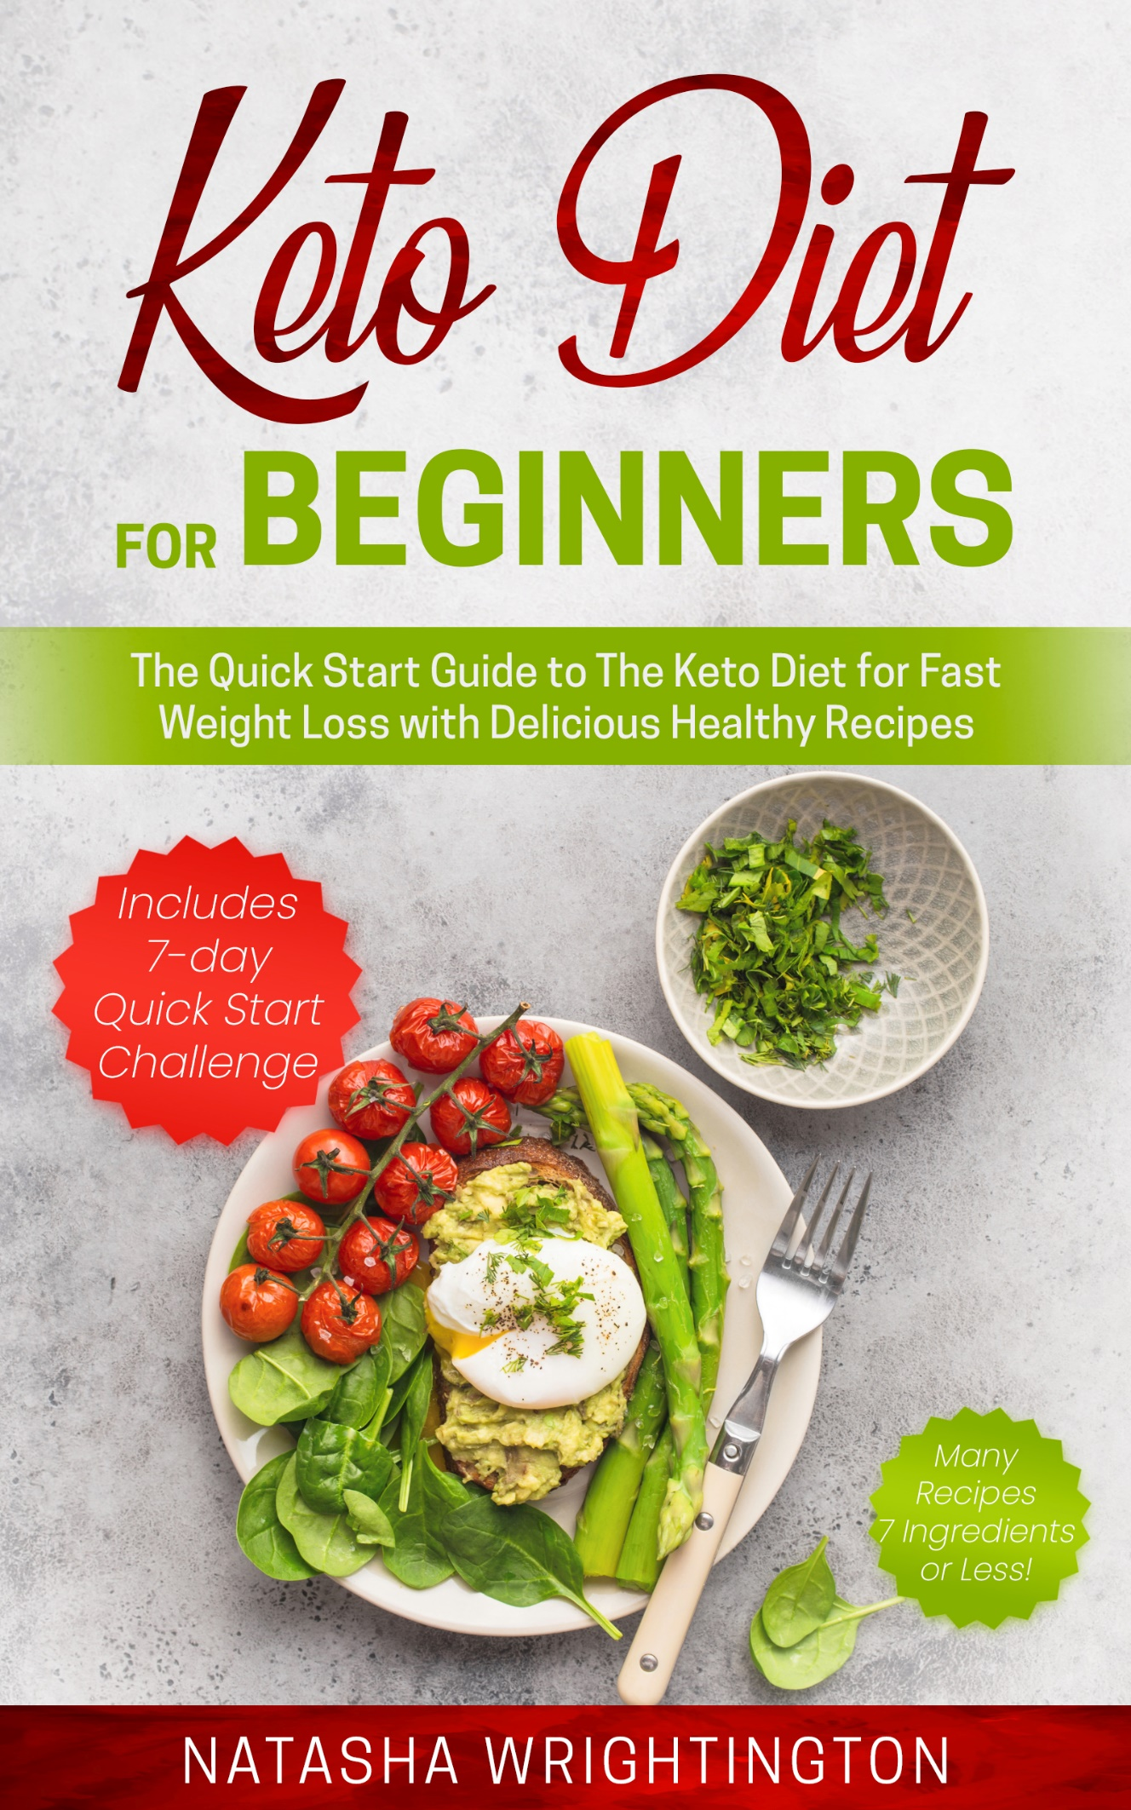

**KETO DIET FOR**

**BEGINNERS**

**The Quick Start Guide to the Keto Diet for Fast Weight Loss with Delicious Healthy Recipes**

**Includes 7-Day Quick Start Challenge**

First Edition

**Natasha Wrightington**

**This edition first published in Great Britain in 2020**

Copyright © 2020 by Natasha Wrightington. All rights reserved. All rights for this book presented belong exclusively to the author. It is illegal to reproduce, duplicate or transmit any part of this document in either electronic means or printed format without the written permission of the author. Recording of this publication is strictly prohibited.

**Check with you doctor**

It is important that before starting this or any other diet that you consult your doctor/physician particularly if you have a diagnosis and have been prescribed medication, as this may need to be adjusted by your doctor whilst on the diet. The ketogenic diet may not be suitable for everyone. Pregnant and breastfeeding women should consult their doctor.

While the author has made every effort to ensure that the information in this book is accurate and up to date, it is advisory only and should not be used as an alternative to seek specialist medical advice. The author is not liable for any damages and cannot be held responsible for actions that may be taken by a reader as a result of reliance on the information in this book which are taken entirely at the reader’s own risk.

|  |
| --- |
| FREE BONUS  EXTRA  7-Day Keto Diet Meal Plan  Grab@  [www.ketodietcoaching.com/freebonus](http://www.ketodietcoaching.com/freebonus) |



*“Courage does not always roar. Sometimes courage is the quiet voice at the end of the day saying, I will try again tomorrow” Mary Anne Roadmacher*

This book is dedicated to everyone who has ever tried to lose weight…finally, a diet that works!

**Table of Contents**

Introduction 7

PART I: The Ketogenic Diet 8

Chapter One: What is Keto? 10

Chapter Two: Losing Weight with the Keto Diet 14

Chapter Three: Getting Started on Keto 24

PART II: The Keto Recipes 30

Chapter Four: Breakfast 32

Bullet Coffee 33

Scrambled Eggs with Parsley and Bacon 34

Keto Coconut Porridge 35

Cinnamon Pancakes with Blackberry Syrup 36

Keto Chocolate Protein Shake 37

Avocado Coconut Smoothie 38

Keto Granola 39

Chapter Five: Lunch 41

Avocado Poached Egg Toast 42

Spicy Crispy Chicken Strips 43

Salmon and Cream Cheese Bagel 44

Broccolli Bites 45

Beef Sizzle Fathead Pizza 46

90 Second Bread Turkey Burger 48

Chicken and Avocado Boats 49

Chapter Six: Dinner 51

Keto Fish and Chips 52

Stir Fry Paprika Chicken 53

Thai Red Curry Beef with Broccoli ‘Rice’ 54

Pan-Fried Steak with Cheesy Cauliflower Mash 56

Tex-Mex Pulled Chicken Fajitas 57

Keto Bread 58

Salmon in Garlic Butter with Roasted Asparagus 59

Chapter Seven: Salads and Soups 61

Beetroot Salad with Raspberry Walnut & Feta Cheese 6

Tuna Avocado Salad  63

Warm Chicken Caesar Salad  64

Creamy Turnip Soup  65

Broccoli and Cauliflower Cheese Soup 66

Sri Lankan Red Coconut Aubergine Soup 67

Chicken Bone Broth Soup 69

Chapter Eight: Sides, Dips and Snacks 71

Jamaican Sweet Chilli Jam 72

Egg-Free Mayo  73

Caesar Salad Dressing  74

Cajun Turnip Wedges  75

Mackerel Pate 76

'Breaded' Mushrooms  77

Keto Crackers 78

Chapter Nine: Desserts 80

New York Lime Cheesecake  81

Blueberry Cauliflower and Lime Muffin  82

Chocolate Avocado Cake  83

Courgette and Lemon Cake  85

Creamy Strawberry Milkshake  86

Salted Caramel Sweets 87

Almond Biscuits 88

PART III: The Keto Challenge: 7-Day Quick Start Plan 89

Chapter Ten: Meal Prep and Meal Plan 91

PART IV: Beyond the 7-Day Challenge 99

Chapter Eleven: Eating Keto with Friends and Family 101

Chapter Twelve: Out and About with Keto 103

Conversion Table 109

Further Resources 110

Acknowledgements 111

About the Author 112

Introduction

Congratulations on purchasing this e-book on the **Keto Diet for Beginners: The Quick Start Guide to the Keto Diet for Fast Weight Loss with Delicious Healthy Recipes**. I am so glad you are here! If you are new to the keto diet or finding it hard to motivate yourself to get started, then this book is for you. Here you will find a step-by-step guide with all the information you need to quick start your diet and enjoy the rapid and exciting weight loss results that everyone is raving about.

If you’re like me, you have tried countless diets and maybe you have had the odd success. However eventually the weight returns, leaving you heavier than ever before, making it harder to lose the weight. The keto diet is different as you will be burning stored fat as well as the fat you eat, making it easier to keep the weight off.

You may be sceptical about the keto diet, wondering if it really is possible to lose 5lbs in your first week and whether keto is just a fad. I am here to show you that it is possible and that theketodiet has been around for over 100 years(some would argue even longer) and you too can achieve these results leading to a happier and healthier life.

If you’re worried that the keto diet is too complicated and restrictive then I am here to show you that keto can be easy. I share a list of **foods to eat** and **foods to avoid**, **substitutes**, a detailed **shopping list** with **easy to find ingredients** as well as **over 40 delicious healthy recipes** (almost half have **7 ingredients or less**)and a **Meal Prep Plan** so you know what to prepare and when**.** My **7-day Quick Start Challenge** is the perfect way to begin your keto journey as it is long enough to see rapid weight loss results but not too long, so you procrastinate, delaying your start. You will soon find that losing weight is just one of the many health benefits you will gain from this life-changing diet. At the end of the 7 days, you’ll find that losing weight is so easy on keto that you probably want to keep going; so, I have included a **FREE BONUS**. Getan **Extra 7-day Keto Diet Meal Plan,** giving you a total of **14 days** of **delicious healthy recipes** all from this book.Sometimes it’s hard to know what to eat for lunch, so I have even included **meal ideas for lunch at work**. I have also included ideas on how to make the **keto diet family-friendly**,so it is easier to stick to your diet and keep enjoying the rapid weight loss results.

**Starting any diet can feel lonely at times so why not reach out to me when you start your** **7-Day Quick Start Challenge by sending me an email** to [**Natasha@ketodietcoaching.com**](mailto:Natasha@ketodietcoaching.com)and let me know how you are getting on. Although I may not be able to respond to all emails, I do read every single one. Remember the sooner you get started the sooner you will achieve your weight loss goals and will feel great.

To your health and weight loss success.

**Natasha** **x**

# **PART I: The Ketogenic Diet**

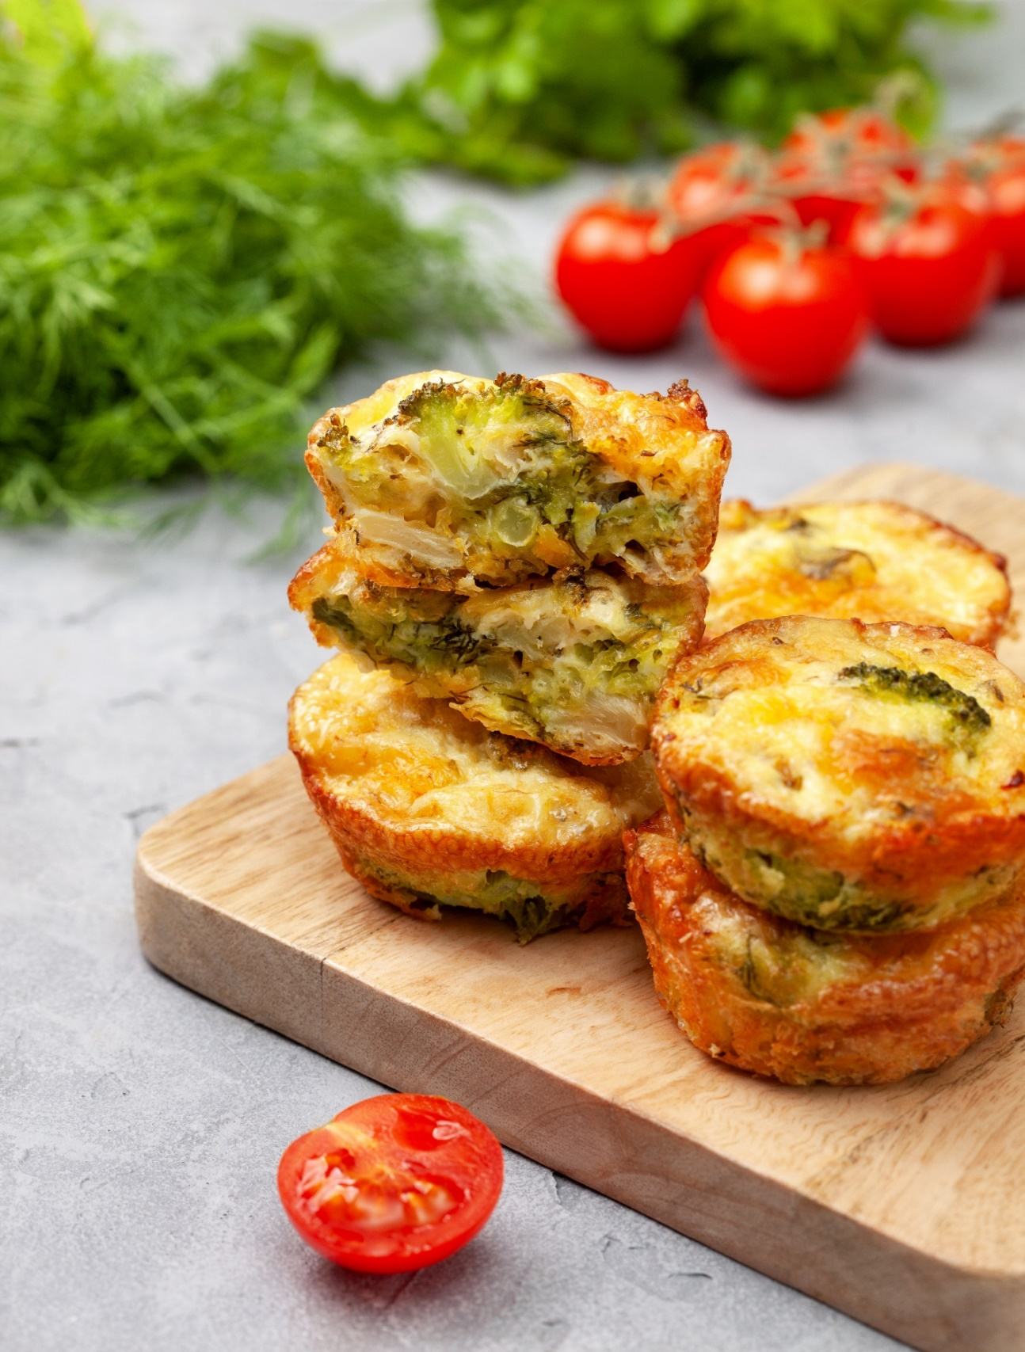

### **Chapter One: What is Keto?**

Keto is short for ketogenic which is a high fat, moderate protein and low carbohydrate diet. Research shows that this combination of macronutrients (which are nutrients our body needs to provide us with energy) has a powerful effect on the body for improved health and rapid weight loss.

### **The Science Behind Keto**

The body uses two sources of fuel for energy; glucose (which has been converted from carbohydrates) and fats. Glucose is the primary source of fuel that the body uses for energy. When the body takes in a low amount of carbs, a moderate amount of protein and a high amount of fat, it quickly burns up the amount of glucose in the body (this takes between 3-4 days) and then turns to fat, as the next available source of energy. The good news is that the body uses up stored fat as well as the fat eaten which it converts into fatty acids stored in the liver. This is then broken down by the liver to produce hormones called ketone bodies which become the body’s source of energy. When enough amounts of ketone bodies are in the blood, a metabolic state known as ketosis takes place resulting in weight loss, lower blood sugar, reduced sugar cravings and lower insulin. Keeping the right daily balance of carbs, protein and fats in your diet is what keeps the body in ketosis and therefore in fat-burning mode.

### **The** **History Behind the Ketogenic Diet**

The ketogenic diet was originally developed in 1923 by Dr Russell Wilder at the Mayo Clinic in Rochester, Minnesota for the treatment of epilepsy. It was also used in the previous century to control diabetes. Wilder’s classic ketogenic diet was very strict, with 90% fats, 6% protein and 4% carbs. Later in this chapter, we will look at the different types of ketogenic diets and will find out more about the one that is most commonly used for weight loss.

### **The Health Benefits of the Ketogenic Diet**

Weight loss has become one of the key benefits of the ketogenic diet, as the body uses up more calories to burn fat than it does to burn carbohydrates resulting in rapid weight loss.

Another health benefit is the reduction of insulin which is a hormone that helps the body to use sugar as fuel and to store it. When the body is in nutritional ketosis (Phinney 2017), this fuel is quickly depleted causing a reduction in insulin. Helping the body to produce less insulin is good news for insulin resistance sufferers as their bodies ignore signals that they have produced enough insulin, so they keep producing more. High levels of insulin in the body are responsible for a slower metabolism making weight loss difficult. It is also associated with obesity, high blood pressure, high cholesterol levels and polycystic ovaries syndrome.

For so long we have been taught that fats are bad for us and are the leading cause of many common health problems. However, the latest research shows that when ‘good fats’ are eaten and the body is in ketosis, it actually raises high-density lipoprotein (HDL) or ‘good’ cholesterol and lowers low-density lipoprotein (LDL) or ‘bad' cholesterol. This may be because your body stops producing cholesterol due to lower levels of insulin.

The ketogenic diet can improve your health by reducing belly fat, increase energy levels and mental clarity, reduce oxidative stress responsible for premature aging, reduce inflammation, improve fertility by managing polycystic ovaries syndrome, lower blood pressure and improve other heart conditions as well as reduce sugar levels which is good news for Type II diabetics.

### **Types of Keto Diets**

There are different types of ketogenic diets

* Standard Ketogenic Diet (SKD) is a diet of high fat (70-75%), moderate protein (15-20%) very low carbs (5-10%).
* Cyclical Ketogenic Diet (CKD) involves being on the keto diet in cycles such as five ketogenic days followed by two high-carb days
* Targeted Ketogenic Diet (TKD) is similar to a standard keto diet; however, it allows for extra carbs to be added pre-workouts. It is good for athletes, body builders and those undergoing intense exercise.
* High-Protein Ketogenic Diet allows for higher protein (35%), slightly less fat than a standard keto diet (60%) and very low carbs (5%).

We are going to be focusing on the Standard Ketogenic Diet as this is one of the most common and most researched keto diets for weight loss.

### **Is the Ketogenic Diet Safe?**

The ketogenic diet has been studied sporadically for over 100 years and is proven to have many health benefits (Miller 2018). There are lots of myths about the keto diet. Research has shown that the ketogenic diet is even safe longer term, of more than a year (Dashti 2007) despite the myths that it is only a short-term diet. Studies have shown that those with high blood glucose levels (diabetics) experienced a significant reduction in their blood glucose from the first week on the keto diet and this continued throughout the study for 56 weeks. (Dashti 2007).

Another myth is that many people confuse the production of ketones in a ketogenic diet known as nutritional ketosis with ketoacidosis, a life-threatening condition for Type I diabetics. Ketoacidosis is high levels of ketones in the blood as well as high levels of glucose. The main differences are that during the ketogenic diet the body produces very low levels of glucose as otherwise the body cannot go into ketosis. Also, the number of ketones produced in the blood during a keto diet is significantly less than what a diabetic will produce during ketoacidosis. Below is a comparison of the production of ketones in a normal diet, a ketogenic diet and in a diabetic ketoacidosis so you can see the difference.

**Normal carbohydrate diet – ketones = 0-0.3mmol/L**

**Ketogenic diet – ketones = 0.05-3 mmol/L**

**Diabetic ketoacidosis – ketones = 10-20 mmol/L**

Research has shown that throughout a ketogenic diet (diet-induced nutritional ketosis), the ketone levels in the blood do not exceed 3 mmol/L (millimolar) (Phinney 2011). In fact, in several studies the average ketone levels were 0.5 mmol/L. (Millar 2018). As you can see, the body can produce low levels of ketones even on a normal carbohydrate diet; however, on a ketogenic diet, the ketone levels produced during nutritional ketosis are significantly lower than in a state of diabetic ketoacidosis.

Although studies show that the keto diet is safe, it is important that you check with your doctor as you would when embarking on any other diet if you are uncertain if it is for you and if you have a medical condition. As your condition improves, your medication may need to be reduced by your general practitioner, so it is important that they know you are about to begin this diet. If you are a diabetic, you will need close monitoring by a doctor and would need to regularly check your blood sugar levels. This is also similar for hypertension sufferers as they too may need medical supervision and would need to regularly check their blood pressure whilst on keto. The ketogenic diet is not recommended for women who are pregnant or who are breastfeeding. It is also not recommended for people with eating disorders, nor is it suitable for children under 18 years of age as they are still growing, but it is okay if they enjoy keto meals with the family alongside regular meals.

Just like any other diet, the keto diet can be abused making it unhealthy. It is important to remain hydrated throughout the day to reduce extra stress to your kidneys and it is advisable that you take a collagen supplement during the first two weeks as alongside water loss, you may lose a small amount of muscle mass. However, studies reveal that once you’ve past these two weeks all your weight loss is fat (Phinney 2011). As well as rapid weight loss, I’m sure you also want the keto diet to improve your health too. It is therefore important that you look after your body. In the next chapter, we will look at ‘clean keto’ and how to get the most out of the ketogenic diet for your health.

### **Key Takeaways**

* Keto is short for ketogenic which is a high fat, moderate protein and low carbohydrate diet
* The body uses two sources of fuel for energy: glucose and ketones. When it runs out of glucose due to a low carb intake it turns to burning fat for energy. This produces ketone bodies in a process called nutritional ketosis
* Research has shown that the keto diet is safe and effective for weight loss and nutritional ketosis is completely different to ketoacidosis in diabetics
* There are several health benefits to the keto diet including rapid weight loss, reduction in belly fat, lower blood pressure and an increase in ‘good’ cholesterol.

In the next chapter, we will take a closer look at how keto works as a diet including how much carbs, protein and fats to eat.

### **Chapter Two: Losing Weight on the Keto Diet**

Now that you know the science behind the keto diet and all the health benefits, we are going to take a closer look at how the keto diet works for rapid weight loss. As we have learnt, the ketogenic diet is a high fat, moderate protein and very low carbohydrate diet. The average person’s diet contains about 45-65% carbohydrates which is about 200-300g of carbs per day. On the keto diet, in order to get into ketosis, the carbohydrate intake needs to be below 50g. In fact, it is recommended that you aim much lower, between 20-25g of carbs per day. As you can see this is going to be a big difference from what you are currently consuming, but don’t worry, in the next chapter I share some helpful tips on how to make this transition almost seamless. In order to stay healthy on the keto diet, it is important to know the different nutrients the body needs to function well and what you will need to consider when getting into keto.

### **Macronutrients**

Macronutrients are nutritional components that provide the body with calories or energy. Macro means large so these nutrients are needed in large amounts. Each food we eat contains a combination of carbohydrates, protein and fat which are macronutrients.

**Carbohydrates** are converted into glucose as the body’s main energy source. When glucose enters your bloodstream, it causes blood sugar levels to rise immediately which then sends a signal to the pancreas to produce insulin. This hormone moves glucose out of the blood and into the cells making up the structure of DNA and cell walls. The body also uses glucose for red blood cells and a small amount for brain function and kidneys; however, the body through the liver, can convert amino acids (from protein) and glycerol (from fatty acids) into glucose without carbohydrates, a process known as gluconeogenesis.

There are good and bad carbohydrates and by that, I mean foods which are either whole foods and therefore nutrient dense and supply the body with the necessary vitamins, minerals and fibre; or they are refined and therefore are empty calories with no nutritional value. We will come back to this point later in the chapter when we discuss the difference between ‘clean keto’ and ‘dirty keto.’ **Good sources of carbs to eat on the keto diet are leafy green vegetables, cruciferous vegetables (such as broccoli, cauliflower, brussels sprouts and cabbage), berries, nuts and seeds.**

**Fibre is a complex carbohydrate.** It is only contained in plant-based foods, it is not found in animal products including dairy. It does not contain nutrients or provide the body with energy therefore it has no calories. However, fibre is vital for a healthy digestive system, makes you feel fuller for longer and helps the body remove waste which can potentially be harmful.

There are two types of fibre: soluble and insoluble. **Soluble fibre** when digested forms a glue-like substance in the stomach that binds to fats and sugars which makes it difficult for fibre to be absorbed into the body. **Good sources of soluble fibre to eat on the keto diet are garden peas, nuts and seeds such as chia seeds, lima beans, milled flaxseed, sesame, sunflower, pumpkin and hemp seeds.**

**Insoluble fibre** does not dissolve in the stomach but bulks up by absorbing water, therefore, increasing in size. It forms a natural laxative when passing through the intestines and the colon, therefore, promoting good health. IBS sufferers may need to avoid eating insoluble fibre on an empty stomach. **Good sources of insoluble fibre to eat on the keto diet are nuts and vegetables with skin such as asparagus, bell peppers, broccoli, brussels sprouts, cucumbers, garden peas, mushrooms, tomatoes, squash, zucchinis (courgettes).**

**Protein** helps the body grow and repair muscles, tendons and ligaments as well as nourishes and maintains hair and nails. You may find that whilst on keto your hair and nails grow and look healthier. It is important however not to eat too much protein (more than 30g) whilst on the ketogenic diet because as we have already learnt, the liver, can produce glucose by converting amino acids (from protein) and fatty acids, a process known as gluconeogenesis. If this happens, then your body will start burning glucose for energy instead of fat, taking you out of ketosis. **Good sources of protein for your keto diet are poultry, beef, lamb, bacon, fish, eggs and seeds such as hemp, sunflower, pumpkin, sesame and chia seeds.**

**Fat,** as we have already learnt, is another source of energy for the body. It acts as building blocks for cell membranes and protective insulation for organs. Eating high quality fats on your keto diet is key to your weight loss success and will make you feel full and reduce cravings. It may seem strange to be consuming foods on your keto diet that you would usually avoid on a traditional calorie counting or low carb diet. However, on keto it is important to get your head around eating fat in order to lose weight fast. Research shows that eating good quality fats can actually help with weight loss. You may find initially when you get going on keto that your fat intake is low as subconsciously you may be avoiding it. To help you with this, it is important that you track your fat intake along with the other two macronutrients using a good keto app to ensure you are getting the right balance to kick-start and maintain ketosis. **Good sources of fats for keto are avocado and avocado oil, coconut oil, extra virgin olive oil, hemp oil and hemp seeds, cold water fish like salmon, mackerel and anchovies, eggs, chia seeds, flaxseed and nuts (with the exception of cashews as they are high in carbs).**

**Water** is also considered to be a macronutrient. Although it is not a source of energy for the body, it is, of course, vital for day-to-day functioning and for survival. Water is particularly important on the keto diet because carbohydrates retain a lot of water (some people on a high carbohydrate diet suffer from bloating as a result) and when this intake is reduced, our body releases this water. This is part of the reason why in the first week on the diet you could lose as much as 5lbs. The other reason why water is so important is that the liver flushes out a lot of water during the process of producing ketones so you might feel dehydrated. **Aim to drink about 2 litres a day of pure water in addition to drinking tea and coffee.**

### **Micronutrients**

**Micronutrients** are also nutritional components. They help with energy production from food. They are called micro as the body needs them in small amounts; however, they are known as ‘essential nutrients’ because they have an important role in normal body function and can reduce oxidative stress. Micronutrients are vitamins and minerals.

**Vitamins** are produced by animals and plants and are not synthesized in the body (except for vitamin D).They help to normalise metabolism, form and repair cells as well regulate them. They convert food into energy, help the body with immune function and blood clotting as well as other vital functions. There are 13 essential vitamins in total and there are two types: fat-soluble and water-soluble.

**Fat-soluble** vitamins are A, D, E and K. They are stored in the body when dietary fat is consumed and therefore daily intake is unnecessary. Too much of these vitamins can be harmful. **Good sources of fat-soluble vitamins to eat on the keto diet are avocados, avocado oil and fish liver oil, cheese, butter, milk, plain Greek yoghurt, ice-cream (unsweetened), eggs, cabbage, broccoli, kale, spinach and other green leafy vegetables, fish (fatty fish and shrimp), pumpkin, cantaloupe and nuts.**

**Water-soluble** vitamins are easily lost through bodily fluids and therefore is generally recommended to be taken daily as for the most part the body does not store it. There are of course exceptions such as B12 which is stored in the liver (as long as a year!) and some research suggests this is the same for B6 and Folate. However, as the body uses up a lot of water on the keto diet, a good daily supply is recommended. **Good sources of water-soluble vitamins to eat on the keto diet are bell peppers, ham, watermelon, plain Greek yoghurt, cheese, butter, meat, poultry, fish, mushrooms, broccoli, avocados, tofu (but not soybean), peanuts and peanut butter, green peas, asparagus, spinach, strawberries and tomatoes.**

**Minerals** are digested into the body from water, plants or by consuming animals that have eaten them. They play a vital role in producing enzymes and hormones, bone health and growth, strong teeth and vision. They are important for the healthy function of the nervous system and biological processes as well as for fluid and electrolyte balance and metabolism. There are two types of minerals: **macrominerals and microminerals** also known as trace minerals.

**Macrominerals** are needed in large amounts in the body. They include calcium, chloride, magnesium, phosphorous, potassium, sodium and sulphur. **Good sources of macrominerals to eat on the keto diet are; cheese, butter, milk, plain Greek yoghurt, kale and spinach and other green leafy vegetables, salmon and other fish, nuts, meat, poultry, eggs, peanuts and peanut butter, cruciferous vegetables such as broccoli, cauliflower and brussels sprouts, berries, garlic, onions, soy sauce and table salt.**

**Microminerals** are needed in the body in small amounts and include copper, cobalt, fluoride, iodine, iron, manganese, selenium and zinc. **Good sources of microminerals to eat on the keto diet are meat, turkey and other poultry, fish, including shell fish and other seafood, walnuts, brazil nuts and other nuts (except cashew nuts) seeds, eggs, berries, spinach, garden peas and other green vegetables, tea and milled flaxseed.**

The four key macrominerals that you need to keep an eye on whilst on the keto diet are **calcium, magnesium, potassium and sodium,** as they are essential electrolytes that keep the hydration balance in the body. As previously mentioned, the liver flushes out a lot of water during the process of ketosis and therefore electrolyte levels can change. Low electrolytes are likely to cause the keto flu. (We shall come back to this later in the chapter). If whilst on the keto diet, you feel weak, lethargic, fatigued, moody and irritable, try adding more salt to your food and consider taking a 1g electrolyte supplement from time to time but seek advice from your GP especially if you suffer from hypertension.

**Sodium** is needed in the body to maintain the balance of fluid. It is also important for muscle and nerve function and helps regulate blood pressure levels. **Good sources of sodium to eat on the keto diet are chicken and vegetable broths, cottage cheese, ham, pickles, soy sauce, pork rinds, shrimp, meat, chicken or vegetable stock.**

**Calcium** helps to build strong bones and teeth, regulates muscle contractions and ensures the proper function of blood clotting**. Good sources of calcium to eat on the keto diet are butter, cheese, milk, plain Greek yoghurt, broccoli, cabbage, okra and other green leafy vegetables, fish with edible bones such as sardines and pilchards, poppy seeds and tofu (but not soybean).**

**Potassium** helps the body control the balance of fluids**. Good sources of potassium to eat on the keto diet are broccoli, brussels sprouts, beef, chicken, turkey, nuts, seeds and fish including shellfish.**

**Magnesium** converts the food we eat into energy. It is vital for the normal function of hormones important for bone health and muscle function as well as nervous system function. **Good sources of magnesium to eat on the keto diet are butter, cheese, milk, plain Greek yoghurt, fish, meat, nuts, spinach and other green leafy vegetables and milled flaxseed.**

### **How Much Carbs, Protein and Fats?**

The macronutrient ratios for carbohydrate, protein and fat needed for the body to get into ketosis varies for each person; however, here is a rough guide:

|  |  |  |
| --- | --- | --- |
| **Carbohydrate** | **5-10%** | **20-50g** |
| **Protein** | **15-20%** | **65-70g\*** |
| **Fat** | **70-80%** | **120g-130g** |

\**this is a guide, aim for 1g of protein for 1kg of body weight*

It is important to recognise that the right balance of macronutrients for each person depends on several factors such as your current weight and how active you are. To get a more accurate calculation I would recommend you **download a keto app such as Keto Diet** or **Carb Manager** which will calculate your daily macronutrients. If you find you are not losing weight, then aim towards the lower end of the ratios for carbohydrates and proteins and towards the higher end for fats.

### **Do Calories Count?**

The ketogenic diet like all diets has an element of success based on the number of calories consumed. Fewer calories are likely to result in improved weight loss. Calories, therefore, do count on the keto diet so I would recommend you track them along with your macronutrients. A good keto app will calculate this for you. The lower the calories the faster you will lose weight.

### **What happens if I have a cheat day?**

If you end up eating foods that are high in sugar or carbs so fall out of ketosis, then firstly, don’t beat yourself up. Cravings for sugar and carbs are normal and are likely to happen during the first two weeks on the keto diet. However, the cravings do stop, once your body no longer experiences the sugar spikes in your bloodstream and therefore you will feel less hungry. The trick is to prepare for the cravings at the start of your diet which I show you in part three and four of this book.

The first thing to do is to calculate your macros. It may not be as bad as you had initially thought, and you can try increasing your fat intake and eliminating carbs for the rest of the day. If you really have eaten too many carbs then one of the fastest ways to get back into ketosis is to do a 16/8 intermittent fast. This involves limiting your food intake to an 8-hour window and fasting the remaining 16 hours. One of the easiest ways to do this is to stop eating at 8pm and resume food intake at 12pm the following day. Research has shown that intermittent fasting has similar health benefits to the ketogenic diet in lowering blood pressure, regulating blood sugar levels, reducing inflammation, improving metabolism and renewing brains cells. Intermittent fasting helps you get back into ketosis by quickly depleting your glycogen stores and turning to fat again to produce energy. Another way is by increasing your intake of MCT oil to increase the production of ketones. MCT oil is made up of medium-chain triglycerides which are mainly derived from coconut oil. It is saturated fatty acids which go straight to the liver when digested and are quickly absorbed to produce ketone bodies. Add MCT oil to salads, shakes and to drinks like **Bullet Coffee**.

### **What is the Keto Flu?**

When you start the ketogenic diet, you may notice flu-like symptoms, this is known as the ‘Keto flu’. As you can imagine your body has got used to burning glucose for energy for a long time and what you are trying to do is encourage your body to switch to burning ketones instead. This fuel transition initially can cause symptoms that resemble the flu while your body is making this drastic change. The symptoms are likely to be experienced within the first two weeks. They are:

* brain fog or slow thinking
* constipation
* dehydration
* extreme thirst
* [fatigue](https://www.healthline.com/symptom/fatigue) or low energy
* feeling cold
* getting ill more frequently
* [headache](https://www.healthline.com/health/headache)
* irritability
* muscle cramps
* nausea
* poor sleep
* vomiting

Once these symptoms have passed, you will notice that you feel energised, mentally sharp and focused. However, the keto flu can be reduced and even avoided.

### **Seven Tips to Avoid the Keto Flu**

1. **Reduce your carbohydrate intake gradually.** You are much more likely to experience the keto flu if you suddenly reduce your carbohydrate intake overnight as your body will experience a sudden shock in the changes of fuel from glucose to carbs. Try preparing your body for the switch by dropping your carbohydrate intake down to 200 to 150 to 100 to 50 to 25 over a seven to ten-day period or even longer.
2. **Keep hydrated throughout the day**. Your body will lose water as a result of depleting its glycogen stores (glycogen binds to water) and as a result of the metabolic process of producing ketone bodies. Check the colour of your urine throughout the day to check if you are dehydrated. The colour should be pale yellow.
3. **Add sea salt to your food.** Alongside flushing out water, your body also losses salt so you will need to add salt to your food. You can also drink bullion or **Chicken** **Bone Broth Soup**. However, if you suffer from hypertension, it is not recommended you drink bullion or highly salted foods. Consult with your doctor and check your blood pressure regularly.
4. **Eat foods rich in potassium and magnesium.** This will help keep the balance of fluids in your body, keep you energised and therefore reduce symptoms such as fatigue and muscle cramps.
5. **Eat low carb, rich fibre foods**. Constipation can be a common complaint for some dieters on the keto diet. To avoid this, aim to have a daily intake of low carb, rich fibre foods. You may have come across psyllium husk in lots of keto recipes which is rich in fibre and often added for this reason. If you regularly suffer from constipation, you may want to consider taking psyllium husk as a supplement, which you can purchase online as a powder for cooking or as a supplement.
6. **Get plenty of sleep.** As your body is working hard to switch fuel sources it is important to get plenty of rest so your body can re-charge as you sleep.
7. **Consider taking a high strength vitamin c supplement** before starting the keto diet and during the first two weeks to build up your immune system. If you do end up with the Keto-flu, this will reduce the risk of it developing into the ‘real’ flu due to the additional stress your body is under.

### **How do I know I am in Ketosis?**

As previously mentioned, ketosis is the metabolic state whereby the body breaks down fat stored in the liver and fat taken in the diet, to produce ketone bodies, an alternative source of energy, when the body has used up its glycogen stores.

Being in the state of ketosis is what causes rapid weight loss, so it is important to know whether your body is in this metabolic state and what to do if it isn’t.

The body produces two kinds of ketone bodies during ketosis*: Acetoacetate (AcAc)* and *Beta-hydroxybutyrate*. It also produces *acetone* which is a by-product of Acetoacetate. Each one of these can be measured to check if the body is in ketosis. Acetoacetate can be measured in the urine using a urine strip, Beta-hydroxybutyrate can be measured in the blood using a blood ketone meter and acetone can be measured in the breath using a breath meter however, the latter is deemed to be less reliable out of the three. What you are looking for is elevated levels of ketones above 0.5 millimoles per litre to confirm ketosis.

If you don’t want to go to the trouble of using these devices to measure ketone bodies, there are signs you can look out for during your keto diet to let you know whether you are in the metabolic state of ketosis or not. Here are seven:

1. **Weight loss.** During your first week, you should notice that you have lost weight. Everyone is individual, but anywhere between 2-5lbs is a rough guide. You should continue to lose weight weekly if you continue with your keto diet.
2. **Appetite Suppression**. During ketosis you will feel less hungry than usual. Research is unclear as to why this happens, but it could be that eating higher levels of protein and fat make you feel full. This is good news as eating fewer calories should help you lose weight although it is still important to keep your macronutrient balance between high fats, moderate protein and low carbs to keep your body in ketosis.
3. **Thirst**. The metabolic state of ketosis can cause dehydration as the process of burning fat uses up more water. Carbohydrates also retains water and sodium, so a reduction in carbs means more water is excreted as the body retains less water.
4. **Fatigue** (initially). Your body uses up a lot of energy switching its energy source from carbohydrates to fats so, you are likely to feel tired initially for the first couple of weeks.
5. **Increased energy**. Once your body passes the initial phase of depleting your stored glucose and switches to ketones for energy, you will notice an increase in energy. It can take around four weeks before your body becomes keto-adapted, a state whereby your body automatically turns to fat for energy and uses it efficiently. However, once this passes you will have a sustained level of energy throughout the day. Say goodbye to afternoon slumps and glucose crashes!
6. **Fruity or metallic taste.** As a result of the production of acetone in your body as it breaks down fat in the liver to produce ketones, you may notice a metallic or fruity taste in your mouth. This usually passes after two weeks. Carrying around sugar-free mints or gum to mask the taste can help if you find it a problem. It is also important to drink plenty of water as previously mentioned.
7. **Insomnia**. During the initial stages of the keto diet, you may find that you are struggling to fall asleep and this may be due to the reduction of melatonin however, as your body becomes efficient in using fat, your brain is able to utilise this fuel and keto dieters have reported that their sleep is deeper on the keto diet.

## **Clean Keto vs Dirty Keto**

**Clean keto** encourages the consumption of foods which contain many micronutrients. These foods are considered to be nutrient dense and provide the body with the necessary vitamins and minerals such as vegetables and fruits in particular berries. They are also good quality sources of fat and foods which are ‘whole’, in other words, as close to their natural state as possible. These foods are organic or free-range eggs; grass-fed butter (butter from grass-fed cows) and lean meats; wild-caught seafood such as salmon as opposed to farmed; extra virgin olive oil and leafy green vegetables. Processed foods are generally avoided but eating foods such as bacon are occasionally allowed.

**Dirty keto**, also known as ‘lazy keto’, are foods which often come to mind when people think about keto dieters eating high fat. They are processed and packaged foods and although are low in carbohydrates, they are also low in nutrients too. Consuming them on the keto diet may result in weight loss but are unlikely to offer similar health benefits and may potentially increase health risks. Dirty keto can often be tempting to dieters that do not feel they have the time to complete the meal prep and may succumb to eating fast foods without the carbs. However dirty keto foods can be high in additives which may be inflammatory to pre-existing health conditions. In chapter twelve I share tips on how to do busy keto so you can eat nutrient rich foods no matter how busy you are. I promise you it is possible.

## **Key Takeaways**

* Macronutrients are carbohydrates, protein and fats and provide the body with calories or energy.
* Micronutrients are also important on the keto diet as they provide the body with the necessary vitamins and minerals to function well. Particularly sodium, potassium and magnesium to keep your electrolytes balanced.
* Keto-flu is the state of experiencing flu-like symptoms as a result of the body switching its fuel source from glycogen to ketone bodies.
* Clean keto is consuming foods which are nutrient dense in order to gain the health benefits from the keto diet as well as the rapid weight loss.

In the next chapter, we’re going to learn about the practical steps you need to take in order to get started on your keto diet. Although it is important to understand the theory behind the ketogenic diet, the only way you’re going to lose weight and reap all the health benefits is to actually get started. It can be so tempting to read yet one more book or one more blog post because you don’t feel confident enough. I promise you; the keto diet is far less complicated in practice than you might think. All you need is someone to show you the quick and easy way, and that’s exactly what I am going to do. Ready? Great! Let’s get started.

## **Chapter Three: Getting Started on Keto**

Sometimes people delay starting the keto diet because they feel it is too complicated and confusing, but it really isn’t. Here I explain exactly what you need to do to get onto keto and start losing weight fast.

First off, what to eat and what to avoid. There are a few rules to remember when shopping for keto friendly foods. **Fruits should be avoided** with the exception of berries due to their high fructose content as your body will convert this into glucose which could take you out of ketosis. Blueberries and raspberries, however, should be eaten in moderation as unlike blackberries and strawberries which contain lower carbs, blueberries and raspberries are higher.

Another rule is to **avoid root vegetables** such aspotatoes (including sweet potatoes), carrots, and parsnips as they are higher in carbs. There are exceptions though; turnips are lower in carbs and eating beetroot and ginger occasionally as well as rhubarb as a treat is okay. Think of **eating vegetables above ground**.

The other rule is to **avoid legumes and beans** such as lentils and beans as they are high in carbs. **Avoid processed meats and foods** which we have already discussed in the previous chapter. However, having bacon or sausage for breakfast once a week is okay. Also **avoid fizzy drinks including diet drinks and zero sugar drinks** as these alternative/artificial sugars or sweeteners can take you out of ketosis. Finally **avoid low fat and diet foods** as these are usually processed and contain high amounts of sugar. You also need full fat to help you achieve your daily fat intake goals.

### **Foods to Eat**

|  |  |
| --- | --- |
| **Beverages** | Almond milk (unsweetened), coconut milk (unsweetened), broth (chicken, beef, vegetable), coffee, tea, water |
| **Eggs** | Organic /free-range if budget allows |
| **Fruit** | Blackberry, cantaloupe, coconut, cranberry, lemon, lime, olive, raspberry, strawberry, tomato, watermelon |
| **Full Fat Dairy** | Milk, hard and soft cheese, goat cheese, single and double cream, crème fraiche, sour cream, Greek yoghurt |
| **Healthy Fats** | Avocado, avocado oil, butter, extra virgin olive oil, coconut, coconut oil, coconut cream, ghee, lard, MCT oil, sesame seed oil, other seed and nut oils |
| **Herbs** | Basil, bay leaves, chives, coriander (cilantro), dill, marjoram, mint, oregano, parsley, rosemary, sage, tarragon, thyme |
| **Leafy Greens** | Kale, lettuce, pak choy (bok choy), spinach, watercress |
| ***More* Vegetables** | Asparagus, aubergines (eggplant), bell peppers, broccoli, brussels sprouts, butternut squash, cabbage, cauliflower, celery, celeriac, chilli pepper, courgettes (zucchini), cucumbers, garlic, ginger*, green beans*, jalapenos, leeks, lettuce, mushrooms, okra, olives, onions*, pumpkin, radish*, scotch bonnet, shallots, spring onions, turnips* |
| **Nuts** | Almonds, almond butter, brazil nuts, hazelnuts, macadamias, pecan nuts, pine nuts, pistachio nuts, walnuts |
| **Seeds** | Chia, flax, hemp, poppy, pumpkin, pumpkin seed butter, sesame, sunflower, sunflower seed butter |
| **Spices** | Allspice, black pepper, cardamom, cayenne, chilli pepper, cinnamon, cloves, cumin, fennel, garlic granules, ginger, mustard, nutmeg, onion granules, paprika, salt (sea salt, Himalayan), turmeric*, vanilla |
| **Poultry** | Chicken, duck, turkey, (including unprocessed deli meat) |
| **Red Meat** | Beef, lamb, pork (bacon, sausage), (including unprocessed deli meat) |
| **Oily Fish** | Anchovies, kippers, mackerel, pilchards, salmon, sardines, trout, tuna |
| **White Fish** | Bream, cod, haddock, hake, halibut, plaice, pollock, sea bass, sole |
| **Shellfish** | Calamari, clams, crab, mussels, lobsters, oysters, prawns, scallops, shrimp |
| **Misc.** | Unsweetened dark chocolate at least 70% cocoa, keto protein, collagen powder |

**\****an exception as it is low in carbs or used in low quantities*

## **Foods to Avoid**

|  |  |
| --- | --- |
| **Dried fruit** | Currents, dates, figs, raisins |
| **Fruit** | Apples, apricots, bananas, cherries, clementines, grapes, kiwis, mangos, oranges, papayas, pears, pineapples, plums, pomegranates, all fruit juice |
| **Beans, grains, legumes and pulses** | Beans (black beans, kidney beans, pinto beans, soya beans), chickpeas, split peas, lentils, all pulses including dahl, all grains including rice (white, brown and wild), buckwheat, millet, pearl barley, quinoa |
| **Nuts** | Cashews |
| **Processed foods** | Biscuits, chocolate, crisps, doughnuts, pastries, pies, pizzas, sweets |
| **Processed meats** | Hot dogs, salami, pate, frankfurters, sausage rolls, sausage in batter |
| **Root vegetables and other vegetables** | Artichokes, corn, leeks, parsnips, potatoes, sweet potatoes, yam |
| **Sugar** | Agave syrup, aspartame, coconut sugar, honey, jams, maple syrup, table sugar, artificial sweeteners |
| **Vegetable oils** | Canola oil (rapeseed oil), corn oil, grapeseed oil, margarine, safflower, sunflower oil, soybean oil |
| **Gluten** | Barley, bulgur, corn flour, couscous, oats, pasta, plain flour, rye, self-rising flour, semolina, spelt, wheat, whole wheat, wheat germ |

**Foods in Moderation**

|  |  |
| --- | --- |
| **Baked goods** | Almond flour, coconut flour, cacao powder/nibs, cocoa powder, flaxseed, pure extract (almond, maple, vanilla) |
| **Beverages** | Spirits and liquor (unsweetened), white and red wine (dry) |
| **Dairy** | Full fat cow’s milk |
| **Fruits** | Blueberries, raspberries |
| **Legumes** | Lima beans, peanuts, peanut butter |
| **Root vegetables** | Beetroots, carrots, celeriac, rutabaga, swede |
| **Vegetables** | Garden peas |
| **Sweeteners** | Erythritol, xylitol, monk fruit, stevia |
| **Misc.** | Cold-pressed extra virgin rapeseed oil, soy sauce |
| **Hidden Carbs** |  |

|  |  |
| --- | --- |
| **Milk Alternatives** | Unsweetened almond milk or coconut milk mixed with rice |
| **Tin foods** | Soups, processed meats |
| **Condiments** | Baking powder, barbecue sauce, mayonnaise, passata, tomato sauce, vegetable stock |
| **Sausage and bacon** | With added potato starch |
| **Seasoning** | With added potato starch |

## **Substitute List**

|  |  |
| --- | --- |
| **Cravings** | **Keto Friendly** |
| Bagels | Salmon and Cream Cheese Bagel (p.44) |
| Burger | 90 Second Bread Turkey Burger (p.48) |
| Bread | Keto Bread (p.58) |
| Biscuits | Almond Biscuits (p.88) |
| Cake | Chocolate Avocado Cake (p.83), Courgette and Lemon Cake (p.85­) |
| Cereal | Keto Granola (p.39) |
| Cheesecake | New York Lime Cheesecake (p.81) |
| Chicken strips | Spicy Crispy Chicken Strips (p.43) |
| Chips/Fries | Cajun Turnip Wedges (p.75) |
| Chocolates | Dark chocolate (unsweetened) |
| Crackers | Keto Crackers (p.78) |
| Mash Potato | Cheesy Cauliflower Mash (p.56) |
| Muffin | Blueberry Cauliflower Lime Muffin (p.82) |
| Porridge | Coconut Porridge (p.35) |
| Pancakes | Cinnamon Pancakes with Blackberry Syrup (p.36) |
| Pasta | Spiralised courgettes (zucchini) |
| Pizza | Beef Sizzle Fathead Pizza (p.46) |
| Rice | Broccoli ‘Rice’ (p.54) |
| Sugar | Erythritol, monk fruit |
| Sweets | Salted Caramel Sweets (p.87) |

## **The Keto Pantry**

Here are some staple keto friendly ingredients to keep stocked in your pantry or fridge

|  |  |  |  |  |
| --- | --- | --- | --- | --- |
| **Baking** | **Cooking/**  **drizzling** | **Seasoning**  **/condiments** | **Vegetables/fruits** | **Misc.** |
| almond flour (blanched) | avocado oil | black pepper (freshly grounded) | avocados | coconut milk (unsweetened) |
| coconut flour | coconut oil | sea salt | broccoli /cauliflower (fresh/frozen) | almond milk (unsweetened) |
| baking powder | extra virgin olive oil | garlic granules | cherry tomatoes | almond butter |
| bicarbonate of soda | cold pressed rapeseed oil | onion granules | cucumbers | cheese (mozzarella, cream etc) |
| cacao nibs/powder |  | paprika | mixed leaf salad/lettuce | butter |
| cinnamon |  | mixed herbs (Italian herbs) | blackberries (fresh/frozen) | chia seeds |
| eggs |  | parsley | blueberries (fresh/frozen) | milled flaxseeds |
| erythritol sugar alcohol |  | Dijon mustard | raspberries (fresh/frozen) | nuts |
| vanilla extract |  | vegetable stock | strawberries (fresh/ frozen) | MCT oil |

**Step-by-Step Guide to Starting Keto**

1. Set a start date to begin your keto diet within 7 days

2. Slowly start reducing your carbohydrate intake over the 7 days before your start

date. Try reducing carbs in 50g increments per day. E.g. 300-250-200 and so on

3. Download a keto app and begin tracking your carbs

4. Clear out your cupboards, pantry and fridge of unfriendly keto foods

5. 1-2 days before your start date, begin stocking up on keto foods

6. Tell a friend about your intentions to begin your keto diet or announce on social

media for support and accountability

7. 2 days before your keto diet, begin your **Meal Prep** (p.92). Focus on making

substitutes that you regularly eat to help you resist eating the high carb versions

such as bread

8. **Follow the 7-Day Quick Start Keto Challenge**!

9. **Send me an email to** [**Natasha@ketodietcoaching.com**](mailto:Natasha@ketodietcoaching.com) to let me know you

have started!

### **Key Takeaways**

* Eat vegetables above ground, avoid root vegetables (with one or two exceptions) and avoid fruit except berries
* Avoid low fat foods and fizzy drinks including those which are diet and zero sugar
* Reduce your carbohydrates slowly in the countdown to going keto
* Download a keto app to track your macronutrients.

**PART II: The Keto Recipes**

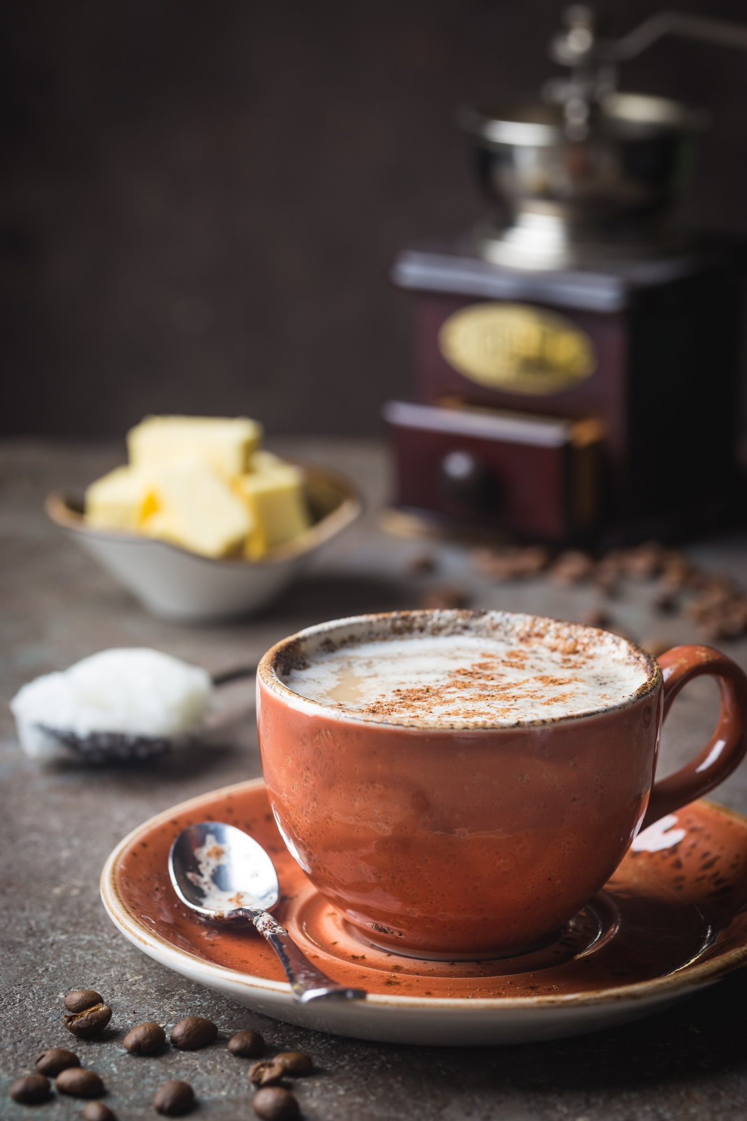

**Chapter Four: Breakfast**

## **Bullet Coffee**

Serves 2 Prep Time: 5 mins

250ml brewed coffee

150ml unsweetened almond milk or coconut milk

1 tbsp double cream

1 tbsp coconut oil

1 tbsp butter

½ tsp vanilla extract

1 tsp collagen powder (optional)

Cinnamon to sprinkle (optional)

1. Brew the coffee and add all the ingredients including the coffee into a blender until smooth
2. Heat in the microwave for 40 to 60 seconds. Sprinkle with cinnamon

|  |  |  |  |
| --- | --- | --- | --- |
| **Nutrition Per Serving** | | | |
| Calories: 198 | Fat: 17.8g | Carbs: 0.5g | Protein: 6.8g |

**Scrambled Eggs with Parsley and Bacon**

Serves 1 Prep Time: 5 mins Cook Time: 5 mins

2 tsp avocado oil

1 strip bacon

1 large egg

3 tbsp whole milk

½ tsp sea salt

½ tsp freshly ground black pepper

1 tbsp parsley chopped fresh (plus extra for garnish)

1. Heat a frying pan on low to medium heat. Add the oil
2. Chop the bacon into small pieces and fry in the pan for 1 minute on each side
3. In a bowl whisk the egg and milk. Add the seasoning
4. Add the egg mixture to the frying pan and mix together until the egg is scrambled
5. Remove when cooked and garnish with fresh parsley

|  |  |  |  |
| --- | --- | --- | --- |
| **Nutrition Per Serving** | | | |
| Calories: 437 | Fat: 40.6g | Carbs: 4.1g | Protein: 10.3g |

`

## **Keto Coconut Porridge**

Serves 2 Prep Time: 5 mins Cook Time: 5 mins

2 tbsp coconut flour

2 tbsp collagen powder (optional)

1 tsp ground cinnamon

2 tbsp erythritol sugar

90ml coconut milk (canned)

300ml unsweetened coconut milk (carton)

1 tsp vanilla extract

1. Blend the ingredients in a blender until smooth
2. Place in a saucepan and gently heat on low to medium heat for 3 to 5 minutes
3. Remove before porridge boils

|  |  |  |  |
| --- | --- | --- | --- |
| **Nutrition Per Serving** | | | |
| Calories: 155 | Fat: 13.7g | Carbs: 11.9g | Protein: 6.7g |

**Cinnamon Pancakes with Blackberry Syrup**

Makes 3 Prep Time: 7 mins Cook Time: 15 mins

**Pancakes**

65g almond flour

1 tsp baking powder

1 ½ tbsp erythritol sugar

2 tsp ground cinnamon

Pinch of salt

75ml unsweetened almond milk

1 large egg

1 ½ tsp butter

1 tsp vanilla extract

Avocado oil for frying

**Blackberry Syrup**

50g frozen blackberries

3 ½ tbsp erythritol sugar

3 tbsp water

1. Blend the pancake ingredients in a blender until smooth. Place the batter to one side to rest for 5 to10 minutes
2. Heat a large frying pan. Add a little oil and place on low to medium heat. Pour the batter into the frying pan in small round batches and cook for 90 seconds or until the edges turn brown then flip over and cook for a further 90 seconds and remove
3. Heat the berries, sugar and water in a saucepan. Stir and heat until a syrup is formed
4. Serve the syrup with the pancakes

|  |  |  |  |  |
| --- | --- | --- | --- | --- |
| **Nutrition Per Serving** | | | | |
|  | | | |
| Calories: 244 | Fat: 22.6g | Carbs: 5.4g | Protein: 5.2g | |

## **Keto Chocolate Protein Shake**

Serves 1 Prep Time: 5 mins

50g keto protein

15g collagen powder

1 tbsp raw cacao nibs or cacao powder

1 tbsp milled flaxseed

300ml unsweetened almond milk

1 tbsp MCT oil

1. Blend the ingredients in a blender until smooth

|  |  |  |  |
| --- | --- | --- | --- |
| **Nutrition Per Serving** | | | |
| Calories: 231 | Fat: 28.7g | Carbs: 7g | Protein: 36.3g |

## **Avocado and Coconut Smoothie**

Serves 1 Prep Time: 5 mins

1 avocado

200ml unsweetened almond milk

2 tbsp coconut milk (canned)

1 tsp almond butter

1 tsp pumpkin seed butter (optional)

1 tbsp MCT oil or coconut oil

2 tsp erythritol sugar

½ lime

Chia seeds to garnish (optional)

1. Blend the ingredients in a blender until smooth
2. Garnish with chia seeds

|  |  |  |  |
| --- | --- | --- | --- |
| **Nutrition Per Serving** | | | |
| Calories: 610 | Fat: 56.8g | Carbs: 5g | Protein: 9g |

## **Keto Granola**

Serves 9 Prep Time: 10-12 mins Cook Time: 15-20 mins

50g whole almonds

50g walnuts

50g pecans

50g brazil nuts or hazelnuts

1 tbsp unsweetened almond milk (plus extra to serve)

1 tbsp sunflower seeds

1 tbsp pumpkin seeds

1 tbsp flax seeds or chia seeds

1 tbsp maca powder (optional)

1 tsp cinnamon (optional)

1 tsp Madagascan vanilla extract

3 tbsp erythritol sugar

1 tbsp coconut oil

1 tbsp almond flakes

1 tbsp unsweetened desiccated coconut

1. Mix all the ingredients in a bowl (except the almond flakes and desiccated coconut)
2. Place on a baking sheet on a baking tray and spread out the granola mixture. Bake at 180c/Gas Mark 4 for 10 to 15 minutes

|  |  |  |  |
| --- | --- | --- | --- |
| **Nutrition Per Serving** | | | |
| Calories: 220 | Fat: 19.6g | Carbs: 11.9g | Protein: 6.7g |

1. Remove and leave to cool. Serve with almond flakes, desiccated coconut and unsweetened almond or coconut milk. Store in an airtight container

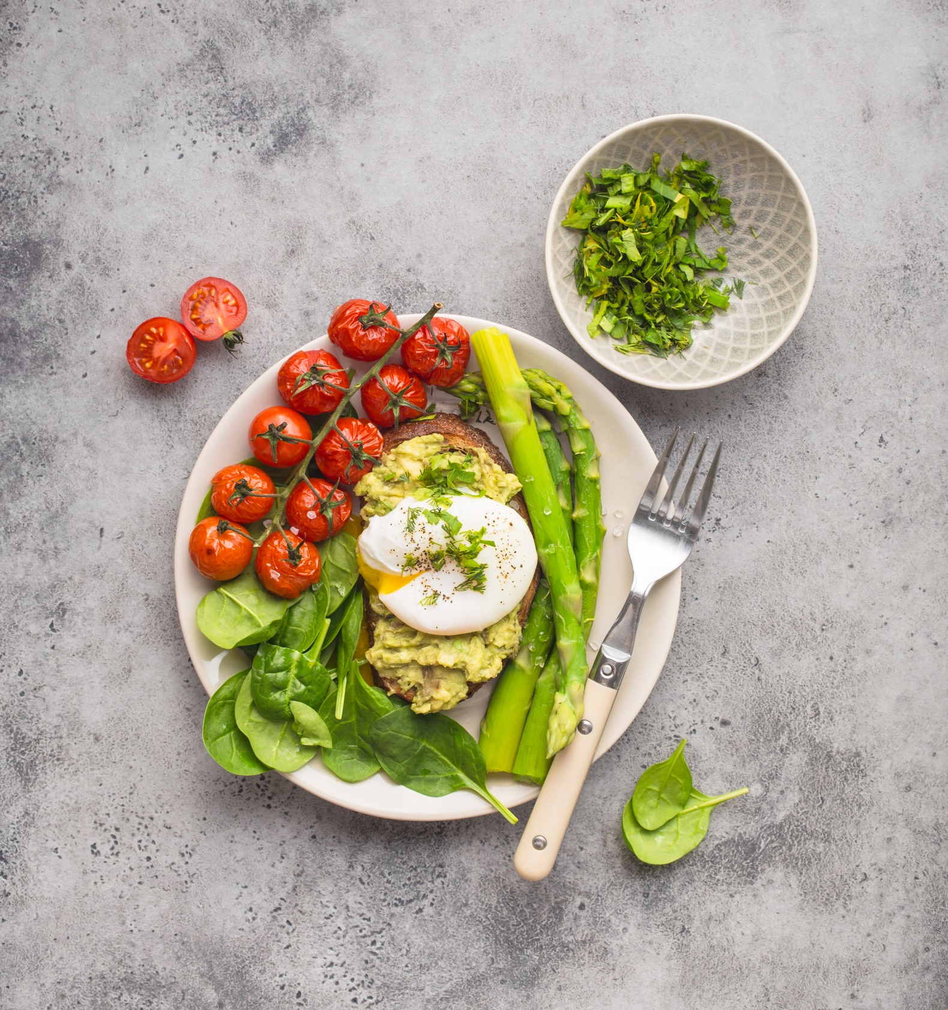

**Chapter Five: Lunch**

## **Avocado Poached Egg Toast**

Serves 1 Prep Time: 5 mins Cook Time: 5 mins

1 large egg

2 slices of toast (**Keto Bread p.58**)

1 avocado

½ tsp sea salt

½ tsp freshly ground black pepper

1 tbsp raw spinach chopped fresh for garnish

1. Fill a saucepan half-way full and bring to the boil
2. Crack open the egg and add to the boiling water. Cook for 3 to 5 minutes depending

on your preference. Add an extra minute if the egg was refrigerated

1. Toast the bread and spread on the avocado
2. Remove the poached egg and place on top of the avocado. Add seasoning
3. Garnish with chopped spinach

|  |  |  |  |
| --- | --- | --- | --- |
| **Nutrition Per Serving** | | | |
| Calories: 553 | Fat: 47.4g | Carbs: 7.6g | Protein: 17.0g |

## **Spicy Crispy Chicken Strips**

Serves 2 Prep Time: 10 mins Cook Time: 20 mins

1 tsp of avocado oil or sesame seed oil

300g chicken breast strips (tenders)

1 lime

50g almond flour

1 tbsp milled flaxseed

1 tsp cayenne pepper

1 tsp turmeric

1 tsp paprika

1 tsp garlic granules

1 tsp onion powder

1 tsp sea salt

1 tsp freshly ground black pepper

1 medium egg

1. Preheat the oven at 180c/Gas Mark 4 and grease the tray with sesame seed oil or avocado oil
2. Cut chicken breast into stripes. Squeeze the lime over the chicken and put to one side
3. In a bowl mix the almond flour, flaxseed and seasoning
4. In a separate bowl add the egg and whisk with a fork
5. Dip the chicken stripes one at a time in the egg and then dip in the bowl with the mix and place on a try a tray. Bake in the oven for 20 minutes or until cooked

|  |  |  |  |
| --- | --- | --- | --- |
| **Nutrition Per Serving** | | | |
| Calories: 430 | Fat: 21.5g | Carbs: 6.2g | Protein: 52.4g |

1. Serve with **Egg-Free Mustard Mayo (p.73)**

## **Salmon and Cream Cheese Bagel**

Makes 3 Prep Time: 10 mins Cook Time: 12-15 mins

**Bagel**

150g grated mozzarella cheese

3 tbsp Philadelphia soft cream cheese

1 medium egg

200g almond flour

2 tsp baking powder

Olive oil for handling the dough

Chia seeds to garnish (optional)

**Filling**

Smoked salmon

Philadelphia soft cream cheese

1. Preheat the oven at 180c/Gas Mark 4
2. Melt the mozzarella and cream cheese in the microwave for 90 seconds
3. Whisk the egg in a separate bowl and mix into the cheese
4. Mix all the dry ingredients together in a separate bowl, then add the cheese mixture and continue to mix until it forms a dough
5. Grease your hands with some olive oil and mould the dough
6. Create 3 bagels ensuring there is a hole in the centre of each one
7. Sprinkle the chia seeds and bake in the oven for 12 to 15 minutes or until lightly browned
8. Serve with the smoked salmon and cream cheese

|  |  |  |  |
| --- | --- | --- | --- |
| **Nutrition Per Serving** | | | |
| Calories: 617 | Fat: 52.4g | Carbs: 7.8g | Protein: 29.5g |

## **Broccoli Bites**

Makes 6 Prep Time: 5-7 mins Cook Time: 20-25 mins

100g fresh broccoli florets

1 red onion (finely chopped)

75g almond flour

½ tsp garlic granules

½ tsp onion granules

¼ tsp sea salt

½ tsp freshly ground black pepper

50g grated cheese

1 tsp Dijon mustard

3 tbsp unsweetened almond milk

1 tsp extra virgin olive oil

Butter for greasing

1. Preheat the oven at 180c/Gas Mark 4
2. Add water to a saucepan and bring to the boil. Then add the broccoli florets and cook for 5 minutes. Remove, drain off the water and rinse with cold water
3. Chop the broccoli and add to a bowl. Add all the ingredients and roughly mix together
4. Blend in a blender for 2 to 3 seconds so broccoli bites are ‘chunky’
5. Grease a muffin tray with butter
6. Add the broccoli mixture into the tray and bake for 20 to 25 minutes or until cooked

|  |  |  |  |
| --- | --- | --- | --- |
| **Nutrition Per Serving** | | | |
| Calories: 141 | Fat: 11.5g | Carbs: 4.3g | Protein: 5.5g |

## **Beef Sizzle Fathead Pizza**

Makes 6 Slices Prep Time: 20 mins Cook Time: 25-30 mins

**Topping**

1 tbsp of avocado oil for frying

60g lean minced beef *

½ tsp garlic granules

½ tsp onion granules

1 tsp dried mixed herbs (Italian seasoning)

1 tsp sea salt

1 tsp freshly ground black pepper

½ green chilli pepper

½ bell pepper

½ small red onion

25g sliced jalapenos (jar)

2 tbsp unsweetened tomato puree

**Crust**

180g grated mozzarella cheese (plus extra for topping)

2 tbsp Philadelphia soft cream cheese

1 large egg

110g almond flour

1 tbsp coconut flour

2 tsp baking powder

¼ tsp sea salt

Olive oil for handling the dough

1. Preheat the oven at 180c/Gas Mark 4
2. Heat a pan with the oil and fry the minced beef with the seasoning for 2 to 3 minutes or until cooked and place to one side
3. Finely chop the green chilli, bell pepper and red onions and place to one side
4. For the crust. Place the mozzarella and cream cheese in the microwave for 90 seconds. Whisk the egg in a separate bowl and then mix together with the cheese
5. Mix all the dry ingredients together in a bowl, then add the cheese mixture and continue to mix until it forms a dough
6. Grease your hands with some olive oil and mould the dough. Place the dough between two baking sheets and roll out to form a circular pizza base. Use a fork to make several holes in the crust
7. Place the pizza crust with the baking sheet underneath onto a baking tray and place in the oven at 180c/Gas Mark 4 for 10 to 12 minutes or until golden
8. Remove the pizza crust from the oven and spread over the tomato puree. Sprinkle the green chilli, bell pepper, red onions and jalapenos and minced beef. Sprinkle the grated cheese on top
9. Return to the oven and cook for a further 10 to 12 minutes or until the cheese is baked

|  |  |  |  |
| --- | --- | --- | --- |
| **Nutrition Per Serving** | | | |
| Calories: 317 | Fat: 24.9g | Carbs: 6.4g | Protein: 17.1g |

\**or substitute with minced chicken breast*

## **90 Second Bread Turkey Burger**

Serves 1 Prep Time: 5 mins Cook Time: 10 mins

**Burger**

90g minced turkey breast *

1 tsp paprika

½ tsp onion granules

½ tsp garlic granules

1 tsp thyme

1 tsp sea salt

1 tsp freshly ground black pepper

Avocado oil for frying

**Bread**

1 medium egg

3 tbsp almond flour

½ tsp baking powder

Pinch of sea salt

Pinch of erythritol sugar

1 tbsp butter

1. For the burger. Add the mince and seasoning in a bowl. Mix together until the meat is fully marinated. Form into a burger
2. Heat a frying pan and add the oil. Fry the burger for 5 to 10 minutes or until cooked
3. In the meantime, whisk the egg and add the ingredients for the bread in a small round microwavable bowl (the size of a bun) and cook for 90 to 100 seconds. Remove and cut the bread in half. Add the turkey burger between the two slices. Serve with a salad

|  |  |  |  |
| --- | --- | --- | --- |
| **Nutrition Per Serving** | | | |
| Calories: 584 | Fat: 43.5g | Carbs: 10.5g | Protein: 40.3g |

\**or substitute with minced beef*

## **Chicken Avocado Boats**

Serves 1 Prep Time: 5 mins Cook Time: 10-12 mins

1 chicken breast

¼ tsp sea salt (plus extra to season to taste)

1 avocado

1 tsp Dijon mustard

½ tsp extra virgin olive oil

½ tsp paprika

2 romaine lettuce leaves

1. Fill a saucepan with water and add the chicken and salt on low to medium heat
2. Bring to the boil and cook for 10 to 12 minutes or until cooked
3. Place the avocado, mustard and oil in a bowl and mix together
4. Remove the chicken and cut into small chunks and add to the avocado dressing with the paprika. Mix together.
5. Fill each of the lettuce ‘boats’ with chicken and avocado
6. Season to taste

|  |  |  |  |
| --- | --- | --- | --- |
| **Nutrition Per Serving** | | | |
| Calories: 485 | Fat: 33.3g | Carbs: 6g | Protein: 32.1g |

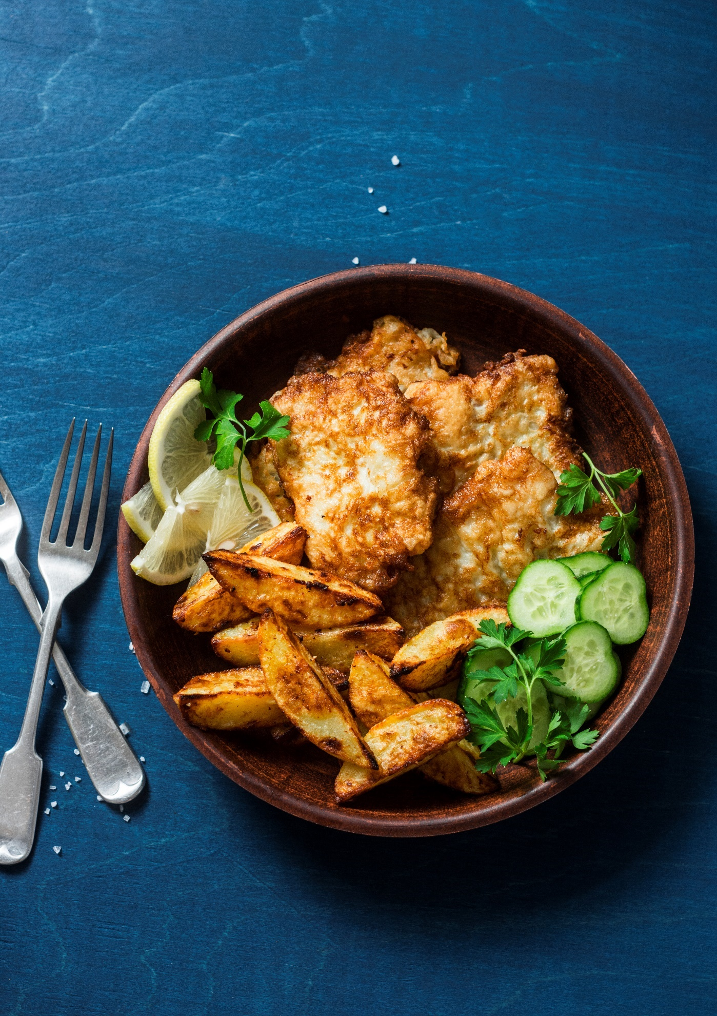

**Chapter Six: Dinner**

## **Keto Fish and Chips**

Serves 2 Prep Time: 10 mins Cook Time: 10-12 mins

2 cod fillets

Juice ½ lemon

1 tsp sea salt

1 tsp freshly ground black pepper

50g almond flour

1 tbsp milled flaxseed

1tsp paprika

½ tsp garlic granules

½ tsp onion granules

1 large egg

Avocado oil for frying

To make Chips see **Cajun Turnip Wedges** **p.75**. (Cut into chips and remove Cajun seasoning)

1. Squeeze lemon juice over the fish, add half the salt and pepper and place to one side
2. In a bowl add the almond flour, flaxseed and seasoning. Mix together
3. In a separate bowl whisk the egg with a fork
4. Heat the avocado oil in a frying pan on medium heat
5. Dip the cod fillet in the egg, then dip in the bowl with the flour mixture and place in the frying pan for 10 to 12 minutes or until the fish is cooked on both sides. Serve with chips

|  |  |  |  |
| --- | --- | --- | --- |
| **Nutrition Per Serving** | | | |
| Calories: 383 | Fat: 27g | Carbs: 3g | Protein: 29g |

**Stir Fry Paprika Chicken**

Serves 2 Prep Time: 10 mins Cook Time: 10 mins

1 tbsp butter

100g mushrooms (thinly sliced)

1 red bell pepper (thinly sliced)

6 pak choi (bok choy) leaves

1 large chicken breast

½ tsp sea salt

½ tsp freshly ground black pepper

1 tsp paprika

½ tsp onion granules

½ tsp garlic granules

1 tbsp pure sesame seed oil

1 tbsp dark soy sauce

1. Heat the butter in a frying pan on low to medium heat and add the mushrooms. Cook for 1 to 2 minutes, then add the bell pepper
2. Roughly chop the pak choi and add to the vegetables
3. Cut the chicken into small slices and place in a bowl. Add the seasoning and toss the chicken in the bowl, ensuring it is well marinated
4. Add the sesame seed oil into the frying pan with the vegetables, then add the chicken. Cook for 3 to 4 minutes
5. Add the dark soy sauce and cook for a further minute or until chicken is cooked

|  |  |  |  |
| --- | --- | --- | --- |
| **Nutrition Per Serving** | | | |
| Calories: 270 | Fat: 19.5g | Carbs: 7.7g | Protein: 20.1g |

## **Thai Red Curry Beef with Broccoli ‘Rice’**

Serves 2 Prep Time: 15 mins Cook Time: 12-15 mins

Sesame seed oil for frying

1 tsp fresh ginger (finely chopped)

2 cloves garlic (finely chopped)

4 pak choi leaves

1 ½ tbsp red Thai curry paste

220g sirloin steak

½ lime

¼ tsp cayenne pepper (optional)

1 tsp paprika

1 tsp sea salt

1 tsp freshly ground black pepper

120ml coconut milk (canned)

50ml water (optional)

1 tbsp fish sauce

½ tsp erythritol sugar

**Broccoli ‘Rice’**

200g of broccoli

2 tsp coconut oil

1 tsp onion granules

1. Heat the sesame oil in a frying pan on a low heat. Add the ginger, garlic and pak choi. Cook for 1 minute, then add the curry paste
2. Chop the steak into small chunks and place in a bowl. Add the juice of ½ lime, cayenne pepper, half the paprika, half the salt and half the black pepper. Toss until the meat is fully covered. Add to the frying pan and cook for 3-4 minutes
3. Add the coconut milk and water (as needed) and simmer
4. Add the fish sauce and sugar. Cook for 2 to 3 minutes or until the beef is cooked and the oil is separated
5. Blend raw broccoli heads in a blender until it forms into ‘rice’
6. Heat the coconut oil in a frying pan and fry the broccoli with the remaining paprika, salt, pepper and onion granules for 3 to 5 minutes or until tender

|  |  |  |  |
| --- | --- | --- | --- |
| **Nutrition Per Serving** | | | |
| Calories: 517 | Fat: 39.8g | Carbs: 12.6g | Protein: 29.9g |

## **Pan-Fried Steak with Cheesy Cauliflower Mash**

Serves 1 Prep Time: 5 Mins Cook Time: 15-20 mins

Avocado oil for frying

1 sirloin steak (or cut of your choice)

¼ tsp cayenne pepper (optional)

½ tsp paprika

½ tsp garlic granules

½ tsp onion granules

½ tsp sea salt plus extra for mash

½ tsp freshly ground black pepper plus extra for mash

**Mash**

100g cauliflower

50g grated cheese

1. Heat the oil in a frying pan
2. Place the steak in a food bag with the seasoning and rub over the steak and remove from bag
3. Fry the steak for 1 minute on one side pressing the steak with the back of a spoon to seal in the flavour. Then turn over and cook for a further minute, again, pressing the steak with the back of a spoon. Then turn over
4. Cook each side further for 1 to 6 minutes depending on preference (rare, medium or well done)
5. Boil the cauliflower in salty water for 5 to 10 minutes or until soft. Drain the water well and place in a blender with the grated cheese. Blend until smooth
6. Season with salt and pepper

|  |  |  |  |
| --- | --- | --- | --- |
| **Nutrition Per Serving** | | | |
| Calories: 657 | Fat: 44.1g | Carbs: 11.9g | Protein: 55.6g |

## **Tex-Mex Pulled Chicken Fajitas**

Serves: 2 Prep Time: 5 mins Cook Time: 15 mins

1 large chicken breast

2 tsp sea salt

Avocado oil for frying

1 small red bell pepper (thinly sliced)

1 small yellow bell pepper (thinly sliced)

1 small red onion

2 tbsp of fajita seasoning (sugar free and corn free)*

1 tsp freshly ground black pepper

1. Place chicken in a saucepan with salty water and bring to the boil. Remove chicken when cooked.
2. Use two forks to ‘pull’ the chicken in opposite directions until shredded
3. Heat the oil in a saucepan. Add the bell peppers and fry for 1 minute. Then add the onions and fry for a further minute.
4. Add the chicken with the seasoning. Fry for 1 to 2 minutes
5. Serve with grated cheese, salsa and a mixed leaf salad

|  |  |  |  |
| --- | --- | --- | --- |
| **Nutrition Per Serving** | | | |
| Calories: 437 | Fat: 10.7g | Carbs: 8.6g | Protein: 40g |

\**or make your own with chilli powder, paprika, cumin, garlic powder, onion powder, mixed Italian herbs and cayenne pepper*

## **Keto Bread**

Makes 16 slices Prep Time: 15 mins Cook Time: 30 mins

5 medium eggs

30g butter

30g coconut oil

200g almond flour

3 tsp baking powder

2 tbsp milled flaxseed or chia seeds

¼ tsp sea salt

¼ erythritol sugar

50ml almond milk

1. Preheat the oven at 180c/Gas Mark 4
2. Warm the eggs in a bowl of warm water and place to one side
3. Melt the butter and coconut oil together and stir
4. Remove the eggs from the water, place in a blender with the butter and oil. Blend until smooth
5. Add all the dry ingredients together in a bowl. Then add the egg mixture with the wet ingredients. Stir together well
6. Place a baking sheet inside a rectangular bread tin. Pour in the bread mixture making sure it is even throughout the tin. Bake for 30 to 35 minutes or until cooked. To check if cooked, place a knife in the centre of the bread, the knife should be clean when removed
7. Once cooled, store in an airtight food container in the fridge

|  |  |  |  |
| --- | --- | --- | --- |
| **Nutrition Per Serving** | | | |
| Calories: 133 | Fat: 6.1g | Carbs: 3.4g | Protein: 9.3g |

## **Salmon in Garlic Butter with Roasted Asparagus**

Serves 1 Prep Time: 10 mins Cook Time: 10-12 mins

1 clove garlic

1 tbsp of butter

1 tsp mixed herbs (Italian herbs)

1 salmon fillet

1 tsp parsley (fresh)

¼ tsp sea salt

1 lemon

50g asparagus

1 tsp of avocado oil

1. Preheat oven at 180c/Gas Mark 4
2. Blend the garlic, butter and mixed herbs in a blender until smooth
3. Place the salmon in a food bag with the seasoning and rub over the fillet. Remove from the bag and place in an oven dish
4. Squeeze the juice of one lemon over the salmon and spread over the garlic butter
5. Place the asparagus into the dish with the salmon and add the avocado oil over the asparagus.
6. Bake in the oven for 10 to 12 minutes or until the salmon is cooked

|  |  |  |  |
| --- | --- | --- | --- |
| **Nutrition Per Serving** | | | |
| Calories: 518 | Fat: 45.1g | Carbs: 3g | Protein: 26.3g |

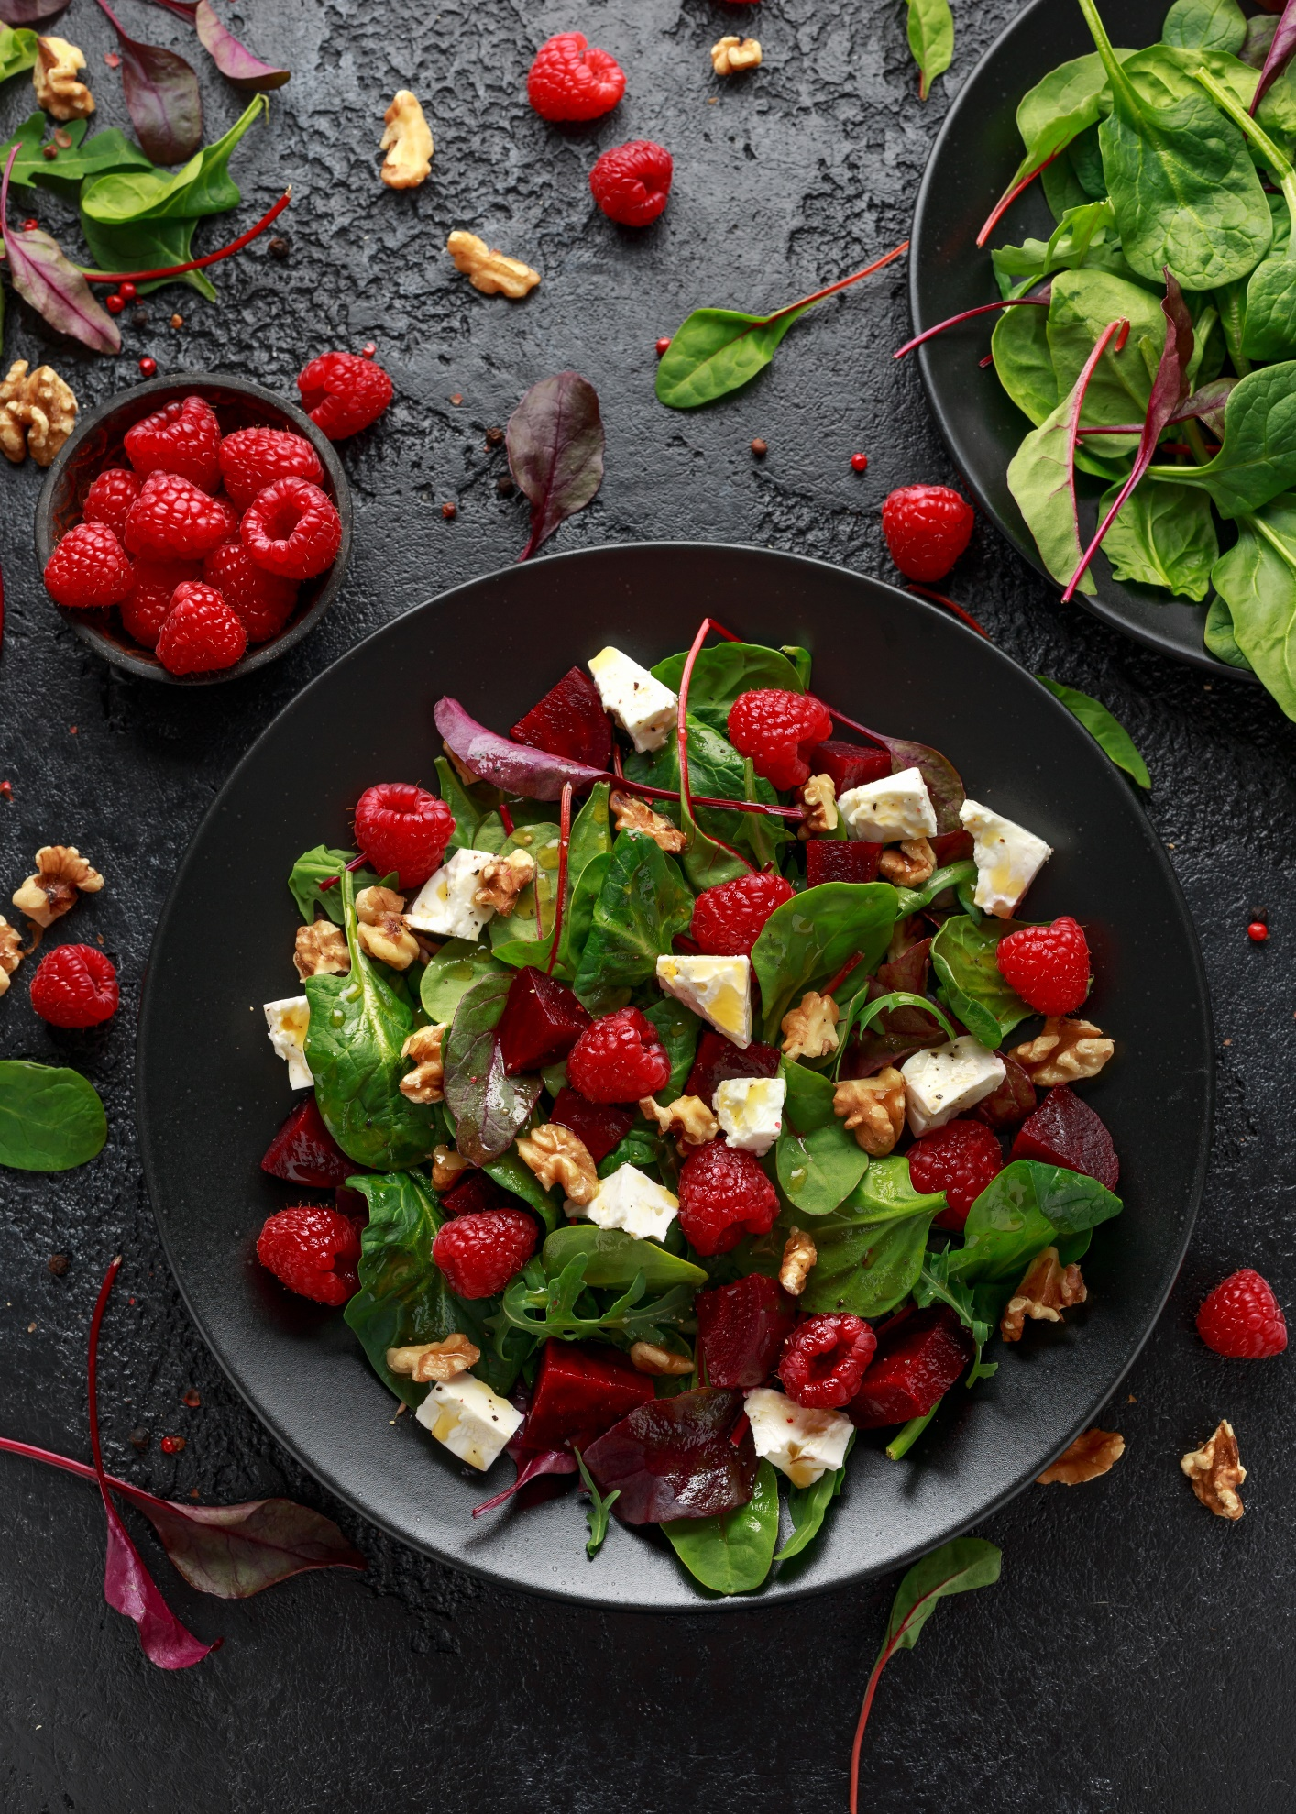

**Chapter Seven: Salads and Soups**

## **Beetroot Salad with Raspberry Walnut and Feta Cheese**

Serves 2 Prep Time: 5 mins

50g baby spinach

1 large beetroot

50g feta cheese

50g walnut halves

75g fresh raspberries

1 tbsp extra virgin olive oil

½ lime

1. Scatter the spinach leaves on a serving plate
2. Slice the beetroot into small chunks and arrange on top
3. Scatter the feta cheese and walnuts
4. Then scatter the raspberries
5. Pour over the olive oil and squeeze over the lime. Season to taste

|  |  |  |  |
| --- | --- | --- | --- |
| **Nutrition Per Serving** | | | |
| Calories: 352 | Fat: 29.9g | Carbs: 10.6g | Protein: 10.3g |

**Tuna Avocado Cucumber Salad**

Serves 2 Prep Time: 5 mins

150g tuna chunks in spring water

1 large avocado

¼ cucumber (finely chopped)

2 tbsp coriander (finely chopped)

½ tsp paprika

½ lime

1 tbsp extra virgin olive oil

1. Drain the tuna from the tin and place in a bowl. Separate with a fork
2. Add the avocado chopped into small pieces and the cucumber
3. Add the coriander, paprika, lime juice and the oil. Gently mix together and season to taste

|  |  |  |  |
| --- | --- | --- | --- |
| **Nutrition Per Serving** | | | |
| Calories: 311 | Fat: 21.9g | Carbs: 5.2g | Protein: 21.2g |

## **Warm Chicken Caesar Salad**

Serves 2 Prep Time: 15-20mins Cook Time: 15-17mins

1 large chicken breast

1 tsp of salt

100g Iceberg lettuce

50g grated cheese

**Caesar Salad Dressing (p.74)**

1. In a saucepan add water, salt and the chicken breast. Cook for 10 to 15 minutes or until cooked right through
2. Make the Caesar dressing if you have not done so previously and place in the fridge
3. Remove the chicken from the saucepan and using two forks, ‘pull’ the chicken in the opposite direction until shredded. Place in a bowl
4. Finely chop the lettuce and add to the bowl

|  |  |  |  |
| --- | --- | --- | --- |
| **Nutrition Per Serving** | | | |
| Calories: 612 | Fat: 57g | Carbs: 4.5g | Protein: 43.5g |

1. Add the cheese and the Caesar dressing and mix together. Season to taste.

## **Creamy Turnip Soup**

Serves 2 Prep Time: 15 mins Cook Time 15-20 mins

1 tbsp butter

1 spring onion (scallion)

¼ red chilli pepper (deseeded)

1 large turnip

50g spinach

300ml vegetable stock

2 tbsp double cream

Fresh parsley to garnish

1. Melt butter in a saucepan on low to medium heat. Finely chop the spring onion and red chilli pepper and add
2. Peel the turnip and chop into small chunks. Add to the saucepan. Cook for 2 to 3 minutes
3. Finely chop the spinach and add
4. Add the vegetable stock and simmer for 10 to15 minutes or until the turnip is soft
5. Blend in a blender for 3 to 4 seconds. Return to the saucepan and stir in the double cream for 1 minute
6. Remove and season to taste. Garnish with the parsley

|  |  |  |  |
| --- | --- | --- | --- |
| **Nutrition Per Serving** | | | |
| Calories: 174 | Fat: 14.9g | Carbs: 9.4g | Protein: 2.4g |

## **Broccoli and Cauliflower Cheese Soup**

Serves 2 Prep Time: 10 mins Cook Time: 10-12 mins

100g broccoli

100g cauliflower

300ml vegetable stock

50g stilton cheese

2 tbsp double cream

1. Boil the vegetables in the vegetable stock. Remove when soft
2. Blend the vegetables with the stock in a blender until smooth
3. Return the soup to the saucepan on low heat and add the cheese. Cook for 1 minute
4. Stir in the double cream and cook for 1 minute. Remove and season to taste

|  |  |  |  |
| --- | --- | --- | --- |
| **Nutrition Per Serving** | | | |
| Calories: 207 | Fat: 33.1g | Carbs: 5.9g | Protein: 17.9g |

## **Sri Lankan Red Coconut Aubergine Soup**

Serves 3 Prep Time: 10 mins Cook Time: 20 mins

½ aubergine (eggplant)

Avocado oil for roasting and frying

2 cloves garlic, crushed

1 small red onion (finely chopped)

1 (1-inch piece) fresh ginger (finely chopped)

½ tsp paprika

¼ tsp cayenne pepper

½ tsp turmeric

½ tsp sea salt

2 tbsp Thai red curry paste

1 tbsp fresh coriander (plus extra for garnish)

200ml coconut milk (canned)

100ml water

1 tsp fish sauce (optional)

1 tsp erythritol sugar

1 lime

1. Preheat the oven at 180c/Gas Mark 4
2. Cut the aubergine into thin slices and brush the avocado oil on either side and roast for 20 minutes or until it browns
3. Heat a frying pan with oil on a low heat and fry the garlic, onion and ginger for a minute
4. Add the aubergine and the seasoning to the frying pan and cook for 1 to 2 minutes
5. Then add the red curry paste and cook for 1 minute
6. Add the fresh coriander and cook for a further minute.
7. Add the coconut milk and water and simmer for 2 to 3 minutes
8. Add the fish sauce and erythritol sugar and cook for a further minute or until the oil separates
9. Garnish with the coriander and serve with a squeeze of lime

|  |  |  |  |
| --- | --- | --- | --- |
| **Nutrition Per Serving** | | | |
| Calories: 238 | Fat: 21.6g | Carbs: 7.3g | Protein: 2g |

## **Chicken Bone Broth Soup**

Serves 2 Prep Time: 5 mins Cook Time: 105 mins

Avocado oil for frying

2 cloves garlic

1 onion (finely chopped)

1 celery (chopped)

1 turnip (chopped)

1 chicken carcass

1 litre chicken stock

½ tsp sea salt

1 tsp freshly ground black pepper

1 sprig of thyme

2 tbsp fresh parsley

1 bay leaf

1. In a saucepan large enough to hold the carcass heat the oil on low heat and fry the garlic and onions
2. Then add the celery and turnip. Fry for 2 to 3 minutes
3. Add the carcass with the salt, pepper, chicken stock along with the sprig of thyme, parsley and bay leaf. Gently simmer on a very low heat for about an 1 hour. Do not let it boil

|  |  |  |  |
| --- | --- | --- | --- |
| **Nutrition Per Serving** | | | |
| Calories: 603 | Fat: 36.3g | Carbs: 10.3g | Protein: 54.7g |

# 

# **Chapter Eight: Sides, Dips and Snacks**

## **Jamaican Sweet Chilli Jam**

Makes 250g Jar Prep Time: 5 mins Cook Time: 40 mins

1 red bell pepper (deseeded)

1 scotch bonnet pepper or red chilli pepper (deseeded)

100g cherry tomatoes

1 tbsp fresh ginger

1 clove garlic

1 tsp mixed spice

1 tsp dried thyme

75ml apple cider vinegar

75g erythritol sugar

1 tbsp coconut oil

1. Blend all the ingredients in a blender until smooth
2. Place into a saucepan and gently heat on low heat for about 40 minutes. Stir frequently until the sauce becomes a thick jam then remove from heat
3. Store in a sterilised jar and keep refrigerated. Serve with cheese or **Keto Crackers (p.78)**

|  |  |  |  |
| --- | --- | --- | --- |
| **Nutrition Per Serving (10g)** | | | |
| Calories: 9 | Fat: 0.6g | Carbs: 0.8g | Protein: 0g |

## **Egg-Free Mayo**

Makes 170g Jar Prep Time: 5 mins

1 avocado

90ml of unsweetened almond milk

1 tbsp coconut milk (canned) optional

2 tsp Dijon mustard

2 tsp extra virgin olive oil

juice ½ lemon

1. Blend all ingredients in a blender until smooth
2. Store in a sterilised jar and keep refrigerated. Lasts up to two weeks

|  |  |  |  |
| --- | --- | --- | --- |
| **Nutrition Per Serving (10g)** | | | |
| Calories: 52 | Fat: 4.8g | Carbs: 0.7g | Protein: 0.6g |

## **Caesar Salad Dressing**

Serves 2 Prep Time: 5 mins

57g anchovies (canned)

1 tbsp Dijon mustard

50ml double cream (heavy cream)

50g freshly grated parmesan cheese

1 garlic clove

1 tsp sea salt

2 tbsp extra virgin olive oil

1 lemon

1. Blend all the ingredients in a blender until smooth. Keep in the fridge until needed Lasts up to 3 days

|  |  |  |  |
| --- | --- | --- | --- |
| **Nutrition Per Serving** | | | |
| Calories: 412 | Fat: 36.5g | Carbs: 2.5g | Protein: 18.5g |

## **Cajun Turnip Wedges**

Serves 1 Prep Time: 10 mins Cook Time: 25-30 mins

1 large turnip

1tsp Cajun seasoning

½ tsp paprika

½ tsp turmeric

½ tsp sea salt

½ tsp freshly ground black pepper

1 tbsp avocado oil (plus extra for frying)

1. Peel the turnip and cut into wedges. Place in a saucepan and boil for 10 minutes on medium heat or until the turnip is softened but still firm
2. Drain the water and place the wedges in a bowl with the seasoning and the oil
3. Toss in the bowl ensuring the wedges are fully marinated
4. Heat a frying pan on low-medium heat with a little oil and fry the wedges for 15 to 20 minutes or until crispy and brown. Add more oil if needed.
5. Serve with your favourite dip

|  |  |  |  |
| --- | --- | --- | --- |
| **Nutrition Per Serving** | | | |
| Calories: 318 | Fat: 27.9g | Carbs: 15.3g | Protein: 2.5g |

**Mackerel Pate**

Serves 2 Prep Time: 10 mins

2 smoked mackerels

100g Philadelphia cream cheese

1 tsp Dijon mustard

Juice ½ lemon

30g radish

½ tsp freshly ground black pepper

1. Remove the skins from the mackerels and place in a serving bowl and mash well with a fork
2. Add the cream cheese and mix well
3. Add the mustard and the lemon juice and mix together
4. Finely chop the radish in thin slices and decorate on top
5. Sprinkle the pepper on top

|  |  |  |  |
| --- | --- | --- | --- |
| **Nutrition Per Serving** | | | |
| Calories: 376 | Fat: 30g | Carbs: 5.1g | Protein: 22g |

# ‘**Breaded’ Mushrooms**

Serves 2 Prep Time: 10-15 mins Cook Time: 10-12 mins

10 white button mushrooms

50g almond flour

1 tbsp milled flaxseed

½ tsp paprika

1tsp dried parsley

1 tsp garlic granules

½ tsp onion granules

½ tsp sea salt

½ tsp freshly grounded black pepper

1 medium egg

Avocado oil for frying

1. Wash the mushrooms and pat dry with a paper towel
2. In a bowl add the almond flour, flaxseed and seasoning. Mix together
3. In a separate bowl whisk the egg with a fork
4. Heat a frying pan on low-medium heat and add the avocado oil
5. Dip the mushrooms in the egg and then dip in the bowl with the flour mixture and place in the frying pan for 10 to 12 minutes or until the mushrooms are golden. Serve with **Egg-Free Mayo (p.74)**

|  |  |  |  |
| --- | --- | --- | --- |
| **Nutrition Per Serving** | | | |
| Calories: 315 | Fat: 26.3g | Carbs: 5g | Protein: 13.5g |

## 

## **Keto Crackers**

Serves 20 Prep Time: 15-20 mins Cook Time: 10-12 mins

100g almond flour

1 tbsp coconut flour

1 tsp baking powder

½ tsp sea salt

1 medium egg

Olive oil for handling the dough

1. Preheat the oven at 180c/Gas Mark 4
2. Mix the dry ingredients together
3. In a separate bowl whisk the egg and add to the dry ingredients along with the olive oil to form a dough. Grease your hands with the oil to mould the dough
4. Place the dough between two baking sheets and roll out
5. Cut into 20 small rectangular shapes and poke each one with a fork
6. Place on a baking tray and cook for 10-12 minutes

|  |  |  |  |
| --- | --- | --- | --- |
| **Nutrition Per Serving** | | | |
| Calories: 39 | Fat: 4.1g | Carbs: 0.8g | Protein: 1.5g |

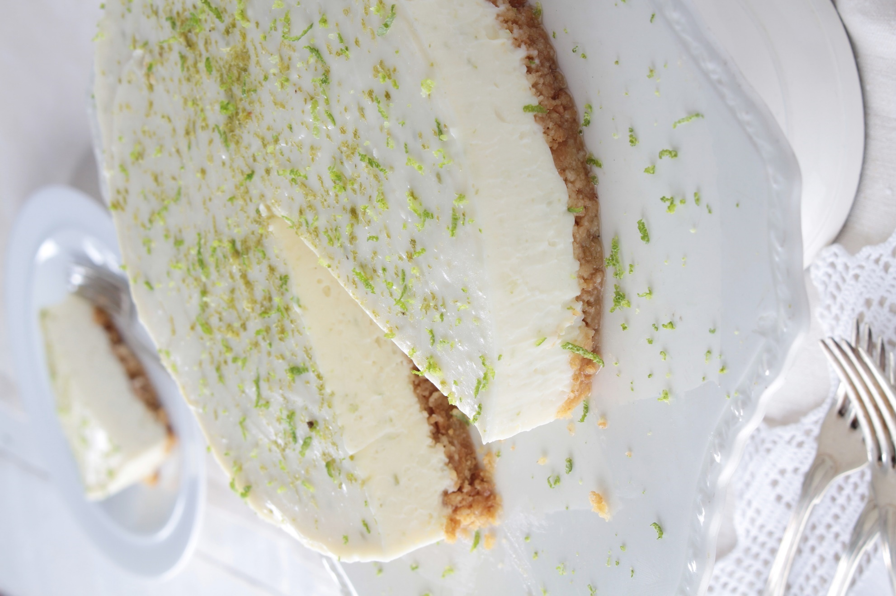

## 

## **Chapter Nine: Desserts**

## **New York Lime Cheesecake**

Serves 10 Prep Time: 30 mins Cook Time: 55-60 mins

**Crust**

200g almond flour

50g coconut flour

75g salted butter (melted) plus extra for greasing

3 tbsp erythritol sugar

**Filling**

250g cream cheese

1 tbsp almond flour

4 tbsp erythritol sugar

3 eggs

120ml sour cream

75ml double cream

Juice and zest 4 small limes

1 tsp vanilla extract

1. Preheat the oven at 180c/Gas Mark 4. For the base, in a bowl mix the almond flour, coconut flour, melted butter and sugar until it forms into a crumbled texture
2. Place into a greased baking tray and pat down evenly. Bake for 10 to 12 minutes
3. For the filling, place all the ingredients in a blender until smooth
4. Remove the base from the oven and leave to cool. Pour the filling on top of the base and smooth evenly

|  |  |  |  |
| --- | --- | --- | --- |
| **Nutrition Per Serving** | | | |
| Calories: 369 | Fat: 34.6g | Carbs: 6g | Protein: 8.9g |

1. Place the baking tin on a tray filled with warm water half-way up the tin and bake for 40 to 45 minutes. Cover with tin foil when it starts to brown (optional)

**Blueberry Cauliflower Lime Muffin**

Serves 6 Prep Time: 10 mins Cook Time:25-30 mins

50g frozen blueberries

Juice 1 lime

50g cauliflower

75g almond flour

2½ tsp baking powder

3 tbsp of erythritol sugar

1 tsp cinnamon

1 large egg

50ml almond milk (unsweetened)

2 tbsp almond butter or pumpkin seed butter

1 tsp vanilla extract

1. Preheat the oven at 180c/Gas Mark 4
2. Place the blueberries and lime to one side and blend the remaining ingredients together in a blender
3. Pour the mixture into a bowl, add the lime juice and fold in the blueberries
4. Place muffin cases inside a muffin tin
5. Pour the mixture into each case and bake for 25 to 30 minutes or until brown. Poke with a knife to check if cooked. The knife should be clean when removed

|  |  |  |  |
| --- | --- | --- | --- |
| **Nutrition Per Serving** | | | |
| Calories: 135 | Fat: 11.2g | Carbs: 4.5g | Protein: 4.7g |

## **Chocolate Avocado Cake**

Serves 12 Prep Time: 10 mins Cook Time: 30 mins

**Cake**

100g almond flour

2 tbsp unsweetened cocoa powder

4 tbsp erythritol sugar

2 tsp baking powder

1 tsp cinnamon

1 avocado

2 medium eggs

60ml coconut milk (canned)

60ml unsweetened almond milk

1 tsp vanilla extract

**Frosting**

1 avocado

3 tbsp organic raw cacao nibs or 90% dark chocolate (unsweetened)

½ tbsp unsweetened cocoa powder

1 tbsp erythritol sugar

2 tbsp double cream

2 tbsp unsweetened almond milk

1. Preheat the oven at 180c/Gas Mark 4
2. Blend all the ingredients for the cake in a blender until smooth.
3. Place a baking sheet into a small baking tin and pour in the cake mixture. Bake for 30 minutes or until the cake is cooked. Place to one side to cool
4. To make the frosting, blend all the ingredients together in a blender ensuring the cacao nibs are blended well
5. When the cake has cooled down smother the cake with the frosting

|  |  |  |  |
| --- | --- | --- | --- |
| **Nutrition Per Serving** | | | |
| Calories: 166 | Fat: 14.6g | Carbs: 6.4g | Protein: 4.6g |

**Courgette and Lemon Cake**

Serves 8  Prep Time: 20 mins Cook Time: 45 mins

200g courgette (grated)

Zest 1 lemon

4 tbsp coconut oil

125g almond flour

75g coconut flour

½ tsp bicarbonate of soda

2 tsp baking powder

1 tsp ground cinnamon

75g erythritol sugar

2 eggs

100ml extra virgin olive oil

1 tsp vanilla extract

Pinch of sea salt

1. Preheat the oven at 180c/Gas Mark 4
2. Grate the courgette and lemon zest and put to one side
3. Melt the coconut oil in a microwave and blend all the ingredients together (except the courgette and lemon zest) in a blender until smooth
4. Place cake batter into a bowl and stir in the grated courgette and lemon zest. Cut the lemon in half and squeeze in the juice. Mix thoroughly
5. Line a rectangular baking pan with baking paper and scoop in the mixture ensuring it is spread evenly. Bake for 45 minutes or until brown and cooked. Insert a knife in the centre of the cake to check if cooked. The knife should be clean when removed

|  |  |  |  |
| --- | --- | --- | --- |
| **Nutrition Per Serving** | | | |
| Calories: 322 | Fat: 29.9g | Carbs: 8g | Protein: 6.9g |

**Creamy Strawberry Milkshake**

Serves 1 Prep Time: 5 mins

50g of frozen strawberries

150ml unsweetened almond milk

100ml double cream

1. Blend all the ingredients in a blender until smooth

|  |  |  |  |
| --- | --- | --- | --- |
| **Nutrition Per Serving** | | | |
| Calories: 408 | Fat: 28.8g | Carbs: 5.6g | Protein: 17.3g |

## **Salted Caramel Sweets**

Serves 4 Cook Time: 10-15 mins Freezer Time: 6-8 hrs

120g butter

50g erythritol sugar

1 tsp vanilla extract

1 tsp pink Himalayan salt or sea salt

1. Melt the butter in a saucepan over medium heat
2. Add the sugar and stir continuously
3. Bring to a gradual boil and continue to stir until the liquid becomes brown in colour
4. Reduce heat if it boils rigorously. Remove from heat and stir in the vanilla and salt
5. Place baking sheet on a baking tray and pour the caramel onto the baking sheet and place in the freezer overnight for a minimum of 6 to 8 hours
6. Once hardened, break sweets into small pieces

|  |  |  |  |
| --- | --- | --- | --- |
| **Nutrition Per Serving** | | | |
| Calories: 218 | Fat: 24.3g | Carbs: 0.3g | Protein: 0.2g |

# **Almond Biscuits**

Serves 20 Prep Time 10-15 mins Cook Time: 10-15 mins

100g almond flour

1 tbsp coconut flour

2 ½ tsp baking powder

¼ tsp sea salt

3 tbsp erythritol sugar

4 tbsp butter

1 medium egg

1 tbsp double cream (heavy cream)

1. Preheat the oven at 180c/Gas Mark 4
2. Mix all the dry ingredients together
3. Melt the butter and place to one side
4. Whisk the eggs in a separate bowl and add the butter and cream
5. Add the creamy egg butter to the dry ingredients and mix well
6. Scoop the dough onto a baking tray to create 12 small round biscuits. Poke each one with a fork
7. Bake in the oven for 10 to 15 minutes

|  |  |  |  |
| --- | --- | --- | --- |
| **Nutrition Per Serving** | | | |
| Calories: 61 | Fat: 5.7g | Carbs: 1g | Protein: 1.5g |

**PART III: The Keto Challenge: 7-Day Quick Start Plan**

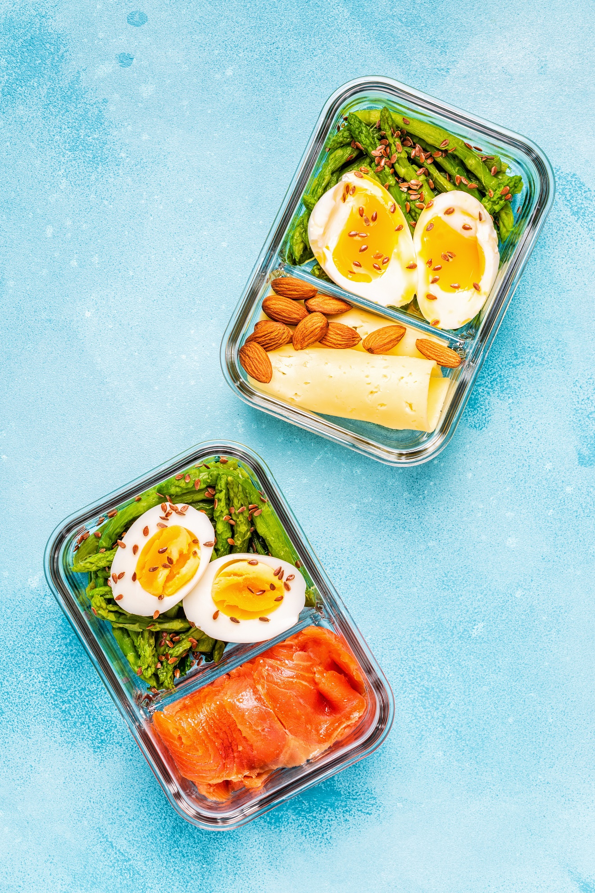

## **Chapter Ten: Meal Prep and Meal Plan**

## **7-Day Quick Start Challenge**

## **Meal Prep Plan**

This simple meal prep plan will help you prepare for your **7-Day Quick Start Challenge** and begins two days before your keto diet start date. This plan starts on a Saturday assuming your keto diet will begin on a Monday. It shows you exactly what you need to prepare over the weekend so that you are ready for your cravings for bread and sugar, as well as what to prepare midweek. Feel free to change the ‘craving ready’ recipes and make them your own. All the recipes are quick and simple and can be prepared in 30 minutes or less! As promised, I have also included a shopping list for the week to make life easier. Remember to send me an email at [natasha@ketodietcoaching.com](mailto:natasha@ketodietcoaching.com) when you start your challenge. I am rooting for you!

|  |  |  |
| --- | --- | --- |
| **Day** | **Bake/Cook** | **Freeze** |
| **Saturday** | **Lemon and Courgette cake**  **Or**  **Salted Caramel Sweets** | **Keep two slices for Monday and Wednesday, then freeze the rest for week 2**  **Keep Salted Caramel Sweets in the freezer so they remain firm** |
| **Sunday** | **Keto Bread**  **for lunch on Monday and dinner on Wednesday, plus extra for snacking**  **Boiled egg for snacking tomorrow** | **Freeze some for week 2** |
| **Monday**  **Evening** | **Broccoli Bites x6 for lunch tomorrow** | **Keep two for Tuesday and Thursday and freeze the rest for week 2** |
| **Tuesday Evening** | **Tuna Avocado Cucumber salad for lunch tomorrow**  **Boiled egg for snacking tomorrow** |  |
| **Thursday**  **Evening** | **Boiled egg and salad for lunch tomorrow** |  |

## **7-Day Quick Start Challenge**

## **Shopping List**

Here is a shopping list of all the foods you will need for a week. The meal plan is designed to ensure there are staple ingredients repeated throughout the week, so this challenge is both varied and economical.

**Beverages**

* Almond milk (unsweetened)
* Coconut milk (unsweetened)
* Coffee
* Tea
* Mineral water

**Baking**

* Almond flour
* Coconut flour
* Baking powder
* Bicarbonate of soda
* Cinnamon
* Eggs
* Erythritol sugar
* Vanilla extract

**Dairy**

* Butter
* Cream cheese
* Cheddar cheese
* Feta cheese
* Grated mozzarella cheese
* Parmesan cheese
* Stilton cheese
* Double cream (heavy cream)
* Greek yoghurt
* Whole milk (optional)

**Fish**

* Anchovy (tin)
* Cod fillets
* Salmon
* Tuna chunks (tin)

**Fruit**

* Blackberries (frozen)
* Blueberries (frozen)
* Strawberries (fresh or frozen)
* Mixed frozen berries

**Meat**

* Bacon
* Lean minced beef/chicken
* Chicken breasts x3
* Whole chicken
* Turkey breast slices (roast)

**Oil**

* Avocado oil
* Coconut oil
* Extra virgin olive oil
* Sesame seed oil

**Seasoning/Condiments**

* Black pepper (freshly grounded)
* Dried mixed herbs (Italian seasoning)
* Cajun seasoning
* Garlic granules
* Onion granules
* Paprika
* Sea salt
* Turmeric
* Dijon mustard
* Soy sauce
* Tomato puree

**Seeds and Nuts**

* Chia seeds
* Milled flaxseed
* Sunflower seeds
* Walnut halves
* Mixed nuts
* Almond butter
* Pumpkin seed butter

**Vegetables**

* Asparagus
* Avocados
* Bell peppers
* Black olives
* Broccoli,
* Cauliflower
* Cherry tomatoes
* Cucumber
* Coriander (fresh)
* Courgettes
* Garden peas
* Garlic cloves
* Green chilli pepper
* Lemon
* Lime
* Mixed leaf salad
* Mushrooms
* Pak choi (bok choy)
* Parsley (fresh)
* Red onion
* Spinach
* Turnip

**Extras**

* Collagen powder
* Keto protein powder
* MCT oil
* Raw cacao nibs or cacao powder

|  |
| --- |
| FREE BONUS  EXTRA  7-Day Keto Diet Meal Plan  Grab@  [www.ketodietcoaching.com/freebonus](http://www.ketodietcoaching.com/freebonus) |

## **7 Day Quick Start Keto Challenge**

**Monday**

Calories: 1392 | Fat: 75% | Carbs: 5% | Protein: 20%

Breakfast

**Bullet Coffee**

Lunch

**Keto Bread** sandwich with roast turkey breast slice and **side salad with extra virgin olive oil

Dinner

**Salmon in Garlic Butter with Roasted Asparagus**

Dessert

**Courgette and Lemon Cake** (x1 slice)

Snacks

Boiled egg, handful of mixed nuts

**Tuesday**

Calories: 1257| Fat: 75% |Carbs: 7%| Protein: 18%

Breakfast

**Keto Chocolate Protein Shake**

Lunch

**Broccoli Bites** x1, side salad, feta cheese, olives and extra virgin olive oil

Dinner

**Stir Fry Paprika Chicken**

Dessert

Greek yoghurt, walnuts, milled flaxseed and sunflower seeds

Snacks

Avocado

**Wednesday**

**Calories: 1241| Fat: 75% |Carbs: 7%| Protein: 18%**

Breakfast

**Bullet Coffee**

Lunch

**Tuna Avocado Cucumber Salad with lettuce**

Dinner

**Broccoli and Cauliflower Soup with Keto Bread**

Dessert

**Courgette and Lemon Cake**

Snacks

Boiled egg, handful of mixed nuts

**Thursday**

Calories: 1257| Fat: 75% |Carbs: 7%| Protein: 18%

Breakfast

**Keto Chocolate Protein Shake**

Lunch

**Broccoli Bites** x1, side salad, feta cheese, olives and extra virgin olive oil

Dinner

**Stir Fry Paprika Chicken**

Dessert

Greek yoghurt, walnuts, milled flaxseed and sunflower seeds

Snacks

Avocado

**Friday**

**Calories: 1266| Fat: 75% |Carbs: 7%| Protein: 18%**

Breakfast

**Bullet Coffee**

Lunch

Boiled egg with side salad and grated cheese

Dinner

**Keto Fish and Chips** with garden peas

Dessert

Berries with Greek yoghurt

Snacks

**Saturday**

Calories: 1266| Fat: 74% |Carbs: 6%| Protein: 20%

Breakfast

**Scrambled Eggs with Parsley and Bacon**

Lunch

**Warm Chicken Caesar Salad**

Dinner

**Beef Sizzle Fathead Pizza** with side salad

Dessert

Strawberries and double cream, milled flaxseed, chia seeds and sunflower seeds

Snacks

Dark chocolate square

**Sunday**

Calories: 1297| Fat: 73% |Carbs: 7%| Protein: 20%

Breakfast

**Cinnamon Pancake with Blackberry Syrup**

Lunch

**Beef Sizzle Fathead Pizza** (leftovers) with salad

Dinner

Cheesy Cauliflower Mash, Broccoli ‘Rice’ with roast chicken and side salad

Dessert

**Blueberry, Cauliflower and Lime Muffin**

Snacks

Boiled egg

*\*purchase from a supermarket deli **side salad – cherry tomatoes, cucumber and mixed leaves*

**Part IV: Beyond the 7-Day Challenge**

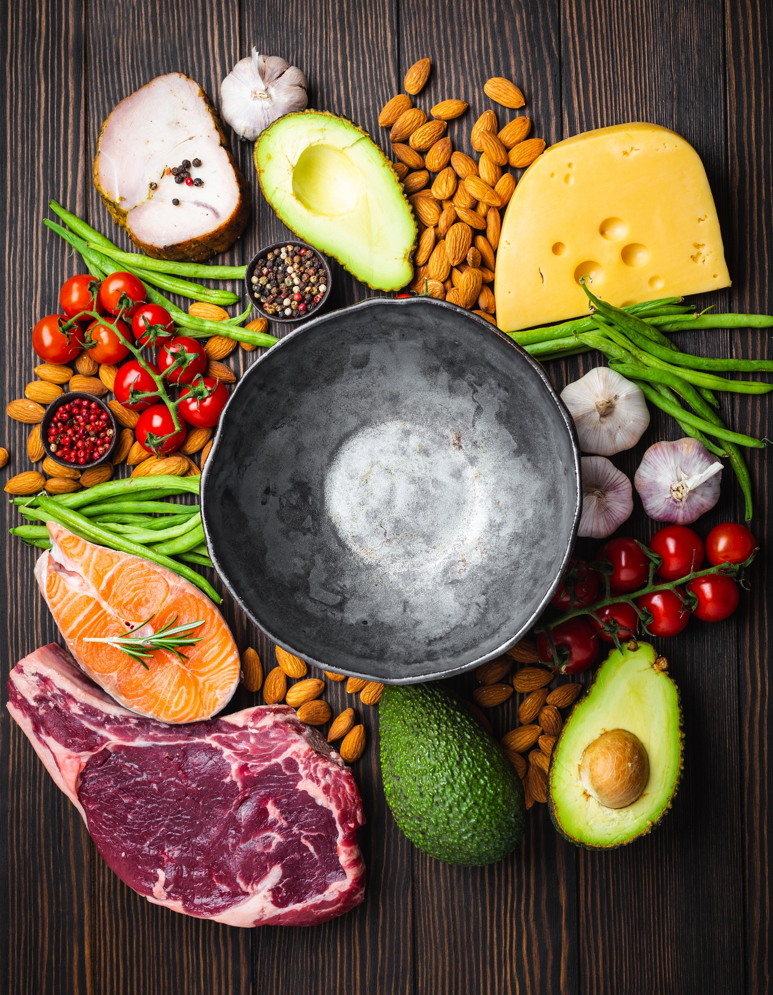

**Chapter Eleven: Eating Keto with Friends and Family**

Congratulations on completing your **7-Day Keto Diet Challenge**! You should be feeling healthier and of course be a few pounds lighter. Now that you have seen the amazing results from the ketogenic diet, chances are you want to keep going until you reach your ideal weight and experience even more health benefits. As a thank you for purchasing this book I am offeringyou a **Free Bonus Extra 7-Day Keto Diet Meal Plan** giving you **a total of 14 days of delicious healthy recipes** all from this book. You can then alternate between the two plans and mix things up**.** It is easier to stick to a diet when you have your friends and family onboard, so I have grouped together all the delicious recipes in this book that are sure to be crowd pleasers. Why not try making some of the recipes with your kids

**Eating Keto with Friends and Family Meal Ideas**

|  |  |  |  |
| --- | --- | --- | --- |
|  | **Partner** | **Kids** | **Friends** |
| **Breakfasts** | **Bullet Coffee**  **Scrambled Eggs with Parsley and Bacon** | **Keto Chocolate Protein Shake**  **Cinnamon Pancakes with Blackberry Syrup** (choose any flavour pancake with any flavour syrup) | **Bullet Coffee**  **Avocado Coconut Smoothie** |
| **Lunches** | **Salmon and Cream Cheese Bagel**  **Warm Chicken Caesar Salad** | **Salmon and Cream Cheese Bagel** (choose any filling)  **90 Second Bread Turkey Burger** (choose any choice of meat) | **Beetroot Salad with Raspberry Walnut and Feta Cheese**  **Broccoli Bites** |
| **Dinners** | **Pan-Fried Steak with Cheesy Cauliflower Mash**  **Salmon in Garlic Butter with Roasted Asparagus** | **Spicy Crispy Chicken Strips** (spicy optional)  **Beef Sizzle Fathead Pizza**  (choose any choice of topping) | **Thai Red Curry Beef with Broccoli ‘Rice’**  **Tex-Mex Pulled Chicken Fajitas** |
| **Desserts** | **New York Lime Cheesecake**  **Courgette and Lemon Cake** | **Blueberry and Cauliflower Muffin** **Lime**  **Salted Caramel Sweets** | **New York Lime Cheesecake**  **Chocolate Avocado Cake** |
| **Snacks** | **Almond Biscuits**  **Jamaican Sweet Chill Jam** with **Keto Crackers** | **Almond Biscuits**  **Creamy Strawberry Milkshake** | **Mackerel Pate** with **Keto Bread**  **Jamaican Sweet Chill Jam** with **Keto crackers** |

**Chapter Twelve: Out and About with Keto**

# It can be hard to follow a diet or any healthy eating plan when you are super busy and rushing around. However, it would be a shame not to maintain a new healthier you by going back to consuming high carbs which will undo all your hard work. Below are some tips as well as meal options for eating at work, on the go and when dining out.

**7 Tips for Staying in Keto When Out and About**

1. Always carry a bag of nuts around with you as an emergency back up
2. Try and plan when you will have breakfast, lunch and dinner so you don’t go hungry because you are eating at odd times. If you do, then you are more likely to grab whatever is available
3. If you know you are going to be out and about then try and take food with you
4. Prepare your meals the night before and make several portions so you can freeze or keep in the fridge. See below for recipes in this book that are great for cooking or baking in bulk and suitable for freezing
5. Stock up on essentials so you do not run out. Have a look at the **Keto Pantry** for ideas
6. When dining out, try and have a look at the menu beforehand, some restaurants have them online. You can also call up the restaurant and ask for low carb suggestions. If you are prepared before you go, you are less likely to feel pressured on the spot to ‘make an exception on this occasion’ and choose non keto friendly foods
7. Have a look at what keto friendly foods are available at your local supermarket near work so that you can plan ahead for those days when you will forget or not have the time to prepare for meals in advance.

**Staying in Keto at work**

**Option 1: Keto Friendly Foods from Work Canteen**

**Breakfast:**

* Coffee with unsweetened almond/coconut milk/whole milk
* Mineral water
* Egg, bacon and sausage with plum tomato

**Snack:**

* Handful of nuts
* Cherry tomatoes
* Bell pepper
* Cheese

**Lunch:**

* Boiled eggs with avocado and salad
* Tuna salad
* Chicken salad
* Meat dish with salad or vegetables (avoid potatoes)
* Ratatouille
* Vegetable cheese bakes
* Meat or vegetable curries

**Option 2: Keto Friendly Foods from Local Supermarket**

**Breakfast:**

* Coffee with unsweetened almond/coconut milk/whole milk
* Mineral water

**Snack:**

* Handful of nuts
* Carrot sticks
* Celery sticks
* Cucumber sticks
* Bell peppers
* Olives
* Cheese slices
* Pumpkin seeds
* Sunflower seeds

**Lunch**:

* Chicken Caesar salad without the croutons
* Roast meat slices (chicken, turkey, beef, ham)
* Tinned fish (anchovies, mackerel, sardines, tuna)
* Salsa (unsweetened)
* Guacamole (unsweetened)
* Tzatziki
* Egg and spinach pot
* High protein chicken breast snacks
* Mixed leaf salad with cucumber, cherry tomato, radish and avocado
* Smoked salmon and cream cheese, cottage cheese or mozzarella

**Dessert:**

* Greek yoghurt with berries
* Strawberries and cream
* Dark chocolate (85%)

**Eating Out**

|  |  |  |
| --- | --- | --- |
| **Restaurant** | **Keto Friendly** | **Avoid** |
| **Chinese** | Chicken, beef, pork, duck, egg, steamed fish, tofu or vegetables, clear thin soups, stir fry vegetables | Rice, noodles, wantons, breaded meats, Thick sauces: sweet and sour sauce, duck sauce, plum sauce, oyster sauce, hoisin sauce |
| **French** | Chicken, beef, pork, lamb, soups (French onion), vegetables in butter, stews, cheese, Hollandaise sauce | Bread, croutons, potatoes, tarts, pastry, rice, crepes |
| **Greek** | Chicken, beef, pork, lamb, fish, simple soups, vegetables, olives, olive oil, lemon, cheese, eggs, tahini, tzatziki, taramasalata, sheep milk, goat milk | Pastries, moussaka, pasta, breaded fish or meat, rice, vine leaves, potatoes |
| **Indian** | Chicken, beef, lamb, fish, vegetable side dishes | Poppadum, potatoes, rice, naan bread, chapatti, lentils, dahl, chickpea dishes |
| **Italian** | Chicken, beef, meatballs, seafood, cheese, marinated vegetables (artichokes, bell peppers), pesto, olive oil, salads, soups, cappuccino, espresso | Breaded meats, croutons, pasta, pizza, desserts |
| **Japanese** | Miso soup, clear broths, ginger, horseradish, negimaki (thinly sliced grilled beef), pickled vegetables, satay chicken, sashimi (fish without rice), seafood salads, vegetable salads, soy sauce | Fried foods, imitation crab meat, noodles, rice, seaweed, sushi, tempura, teriyaki |
| **Mexican** | Beef, chicken fajitas, pork, chorizo, enchilada soups or bowls, cheese, guacamole, jalapeno peppers, salads, salsa, sour cream, seafood | Beans, corn, enchiladas, rice, nachos, tacos, tortillas, quesadillas |

**Recipes Suitable for Freezing or Batch Cooking**

|  |  |
| --- | --- |
| **Breakfast** | **Pancakes** (Cinnamon Pancakes with Blackberry Syrup) |
| **Lunch** | **Bagels** (Salmon and Cream Cheese Bagels), **Broccoli Bites**, **Pizza crust** (Beef Sizzle Fathead Pizza), **Keto Bread** |
| **Dinner** | **Creamy Turnip Soup**, **Broccoli and Cauliflower Cheese Soup**, **Sri Lankan Red Coconut Aubergine Soup**, **Chicken Bone Broth Soup** |
| **Desserts** | **Blueberry Cauliflower and Lime Muffin, Courgette and Lemon** **Cake**, **Chocolate Avocado Cake**, **Salted Caramel Sweets** |

## **7 Tips for Keto Success**

Congratulations on finishing this quick start guide. You now know everything you need in order to achieve your health and weight loss goals on Keto. To keep you losing weight and feeling great, here are my **seven tips for success**:

1. **Reduce your carbs slowly during the countdown phase before starting on Keto**
2. **Track your calories and macronutrients using a keto app**
3. **Only eat when you are hungry and until you are 80% full**
4. **Drink plenty of water throughout the day**
5. **Aim to consume 5 a day of vegetables and fruit to ensure you are getting** enough **vitamins and minerals**
6. **For good bowel health, sprinkle chia seeds and flaxseeds on everything**
7. **Aim to eat just below your protein target, avoid going above**

## **Conversion Table**

|  |  |  |  |  |  |  |
| --- | --- | --- | --- | --- | --- | --- |
| **Cup** | **Ounces** | **Metric** | **TBSP** | **Millilitres** | **Fahrenheit** | **Celsius** |
| 1/16 cup | 1/2 oz | 15 g | 1 | 15 ml | 100 °F | 37 °C |
| 1/8 cup | 1 oz | 29 g | 3 | 30 ml | 150 °F | 65 °C |
| 1/4 cup | 2 oz | 57 g | 4 | 59 ml | 200 °F | 93 °C |
| 1/3 cup | 2.5 oz | 75 g | 5.5 | 79 ml | 250 °F | 121 °C |
| 3/8 cup | 3 oz | 85 g | 6 | 90 ml | 300 °F | 150 °C |
| 1/2 cup | 4 oz | 113 g | 8 | 118 ml | 325 °F | 160 °C |
| 2/3 cup | 5 oz | 141 g | 11 | 158 ml | 350 °F | 180 °C |
| 3/4 cup | 6 oz | 170 g | 12 | 177 ml | 375 °F | 190 °C |
| 1 cup | 8 oz | 227 g | 16 | 240 ml | 400 °F | 200 °C |

## **Further Resources**

**Books**

Phinney, S and Volek, S J (2011). *The Art and Science of Low Carbohydrate Living: An Expert Guide to Making the Life Saving Benefits of Carbohydrate Restriction Sustainable and Enjoyable* Beyond Obesity LLC

**Online Periodicals**

Br J Nutr (Oct 2013). *Very Low Carbohydrate Ketogenic Diet v. Low Fat Diet for Long-term Weight Loss: A Meta-analysis of Randomised Controlled Trials*. Retrieved from <https://www.ncbi.nlm.nih.gov/pubmed/23651522>

Johnstone AM (2008). *Effects of a High Protein Ketogenic Diet on Hunger, Appetite, and Weight Loss in Obese Men Feeding ad* libitum.Retrieved from <https://www.ncbi.nlm.nih.gov/pubmed/18175736>

A Paoli et al. (2014). *Beyond Weight Loss: A Review of the Therapeutic Uses of Very Low Carbohydrate (ketogenic) Diet*. Retrieved from <https://www.ncbi.nlm.nih.gov/pmc/articles/PMC3826507/>

Dashti H M et al (2004). *Long-term Effects of the Ketogenic Diet in Obese Patients.* Retrieved from<https://www.ncbi.nlm.nih.gov/pmc/articles/PMC2716748/>

# Miller et al (2018). *Nutritional Ketosis and Mitohormesis: Potential Implications for Mitochondrial Function and Human Health.* Retrieved from <https://www.ncbi.nlm.nih.gov/pmc/articles/PMC5828461/>

**Acknowledgements**

**Thanks to my husband, for all his expert advice in writing this book.**

# **About the Author**

Natasha Wrightington is a British clinical therapist. She has been passionate about diet and weight loss for over 10 years. She was inspired to write this book after a work colleague negatively commented on her weight. Soon after, she discovered the ketogenic diet, spent over 200 hours reading and researching and lost over 20 pounds.

During her research she could not find a quick start guide for beginners that had all the information to get started without having to read several books or blog posts, so wrote this book.

After friends approached her for advice, her husband suggested she become a Certified Health Coach, which she is currently working on. Natasha is married to a former Personal Trainer and lives between the UK and the US.

|  |
| --- |
| FREE BONUS  EXTRA  7-Day Keto Diet Meal Plan  Grab@  [www.ketodietcoaching.com/freebonus](http://www.ketodietcoaching.com/freebonus) |